How to Upload New Words to the Word Bank

# Uploading on Windows PC Browser (Chrome/Edge/FireFox)

1). Click on Play Game on the homepage

1. 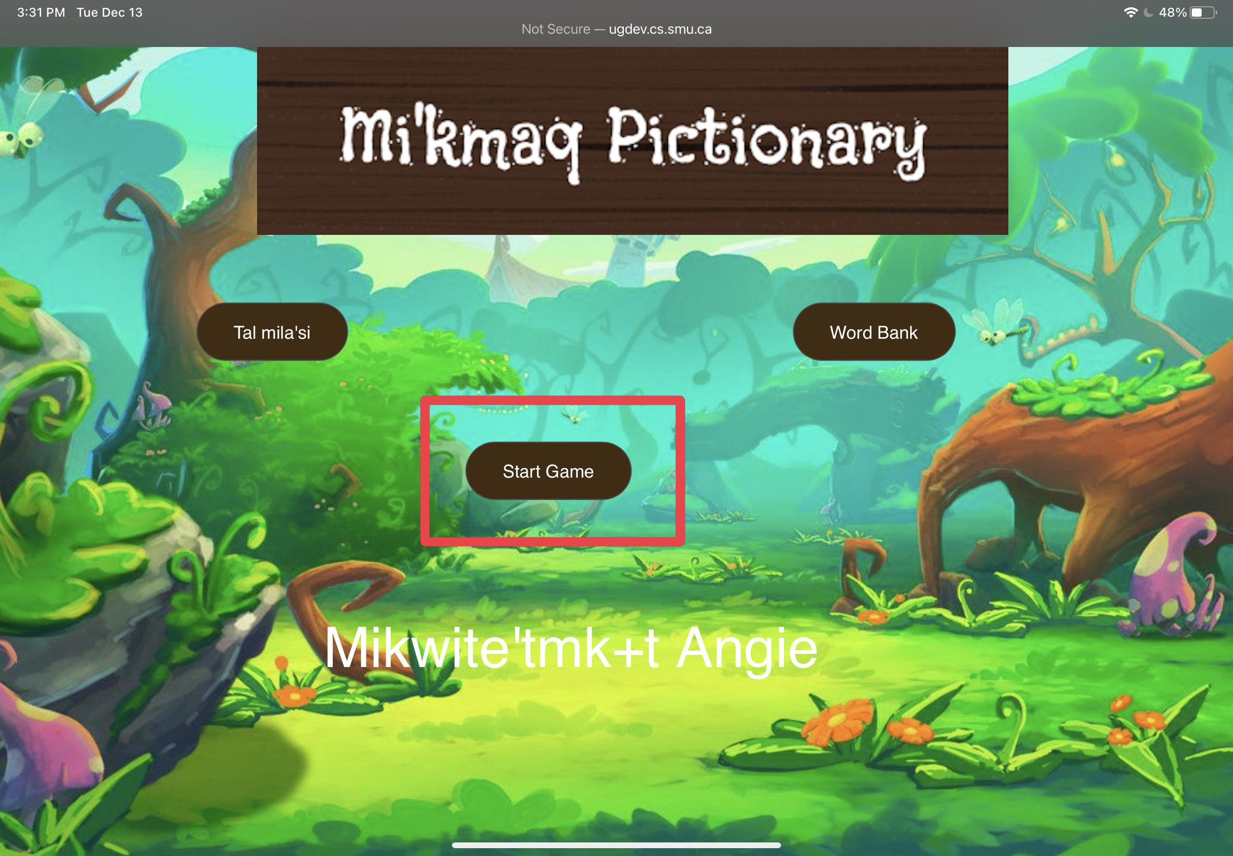

2). Click on the blue lock button

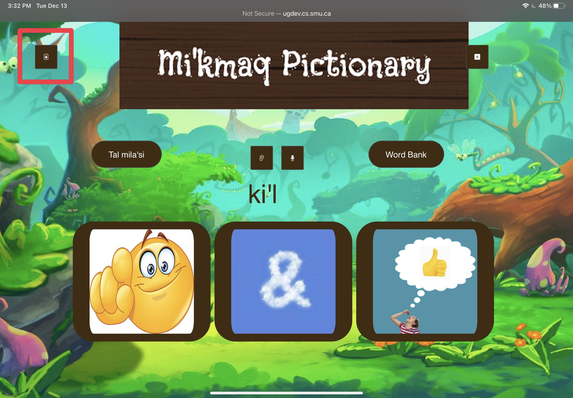

3). Enter password “only me” in the empty box

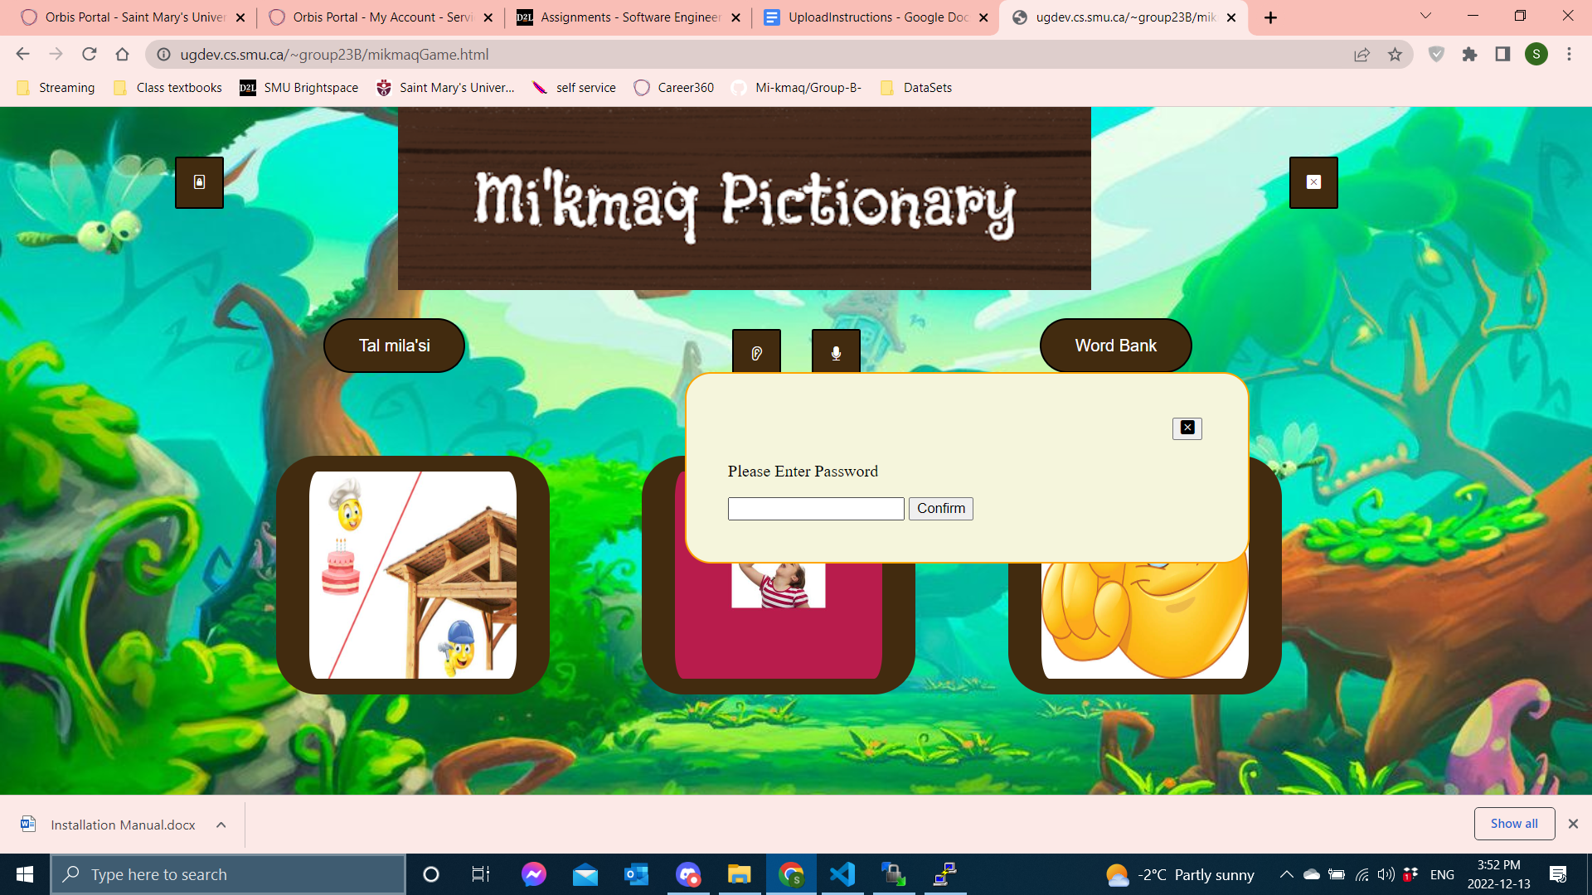

4). Then select the confirm button on the side of the box

5). Click on the 1st “Choose File” button from the left to upload the image of the word you would like to add.

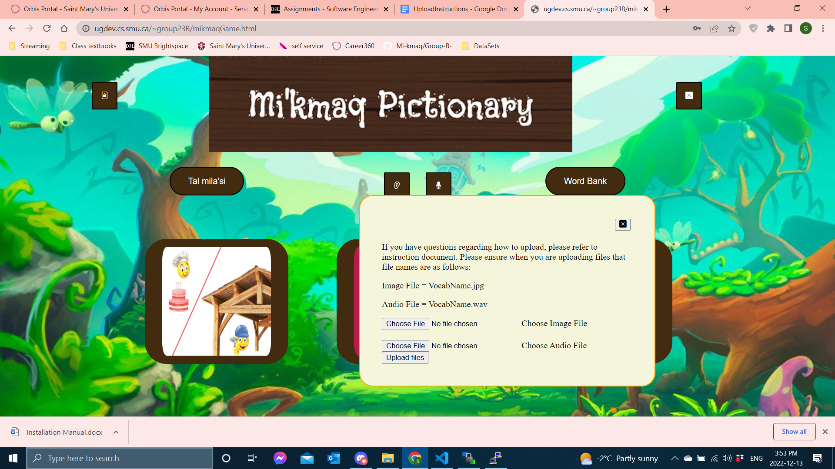

5). Click on the image that you want to add.

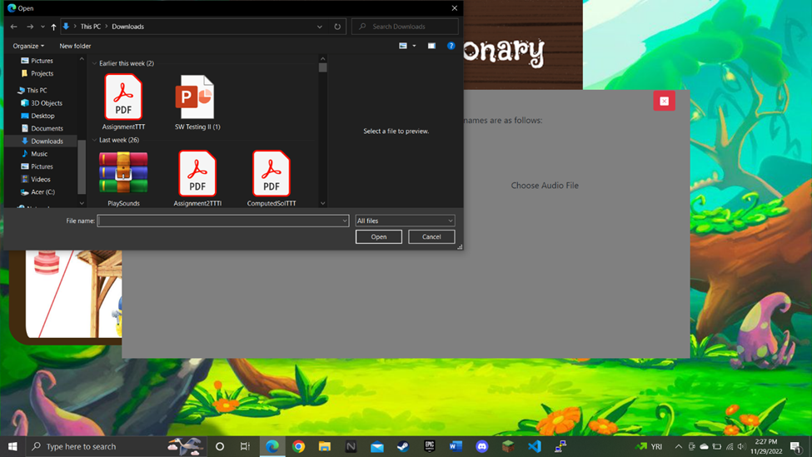

6). Then click the open button to add the image of the word.



7). Click on the 2nd ”Choose File” button to upload the audio of the word you would like to add.



8). Click on the audio file that you want to add.



9). Then click the open button to add the audio.



10). Now, click the “Upload Files” button to add the new word and audio to the game.



11). You should be transported to a page which will tell you if the new word and audio has been successfully uploaded.

12). If there has been an error, click the return button and start from step 1

13). If you have successfully uploaded the new image and audio, click the return button and begin playing the game.

## Recording Audio For New Words

1). Click on the search bar on the task bar at the bottom of the screen.

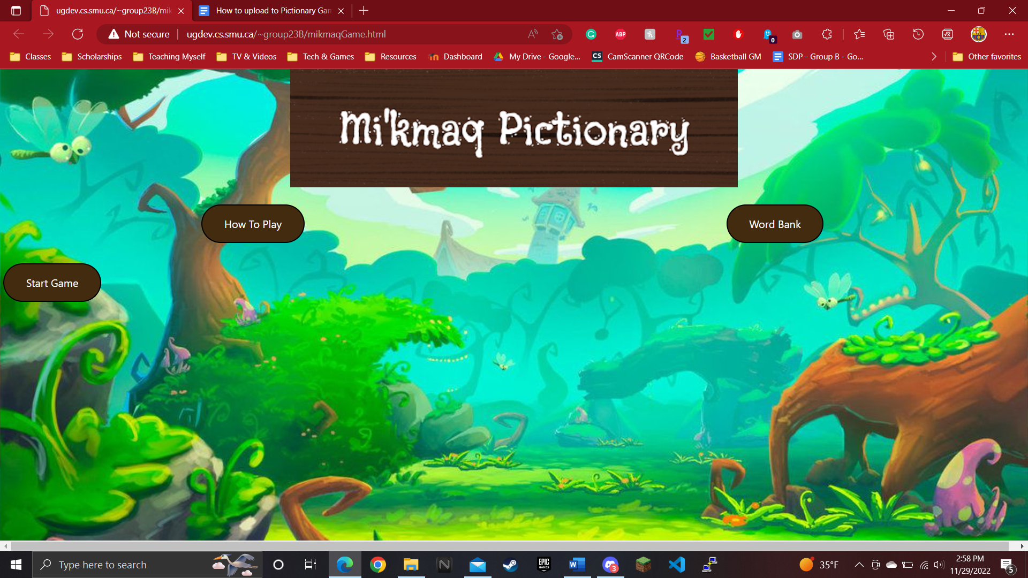

2). Type “Voice Recorder” and click on the application to open the Voice Recorder Application.

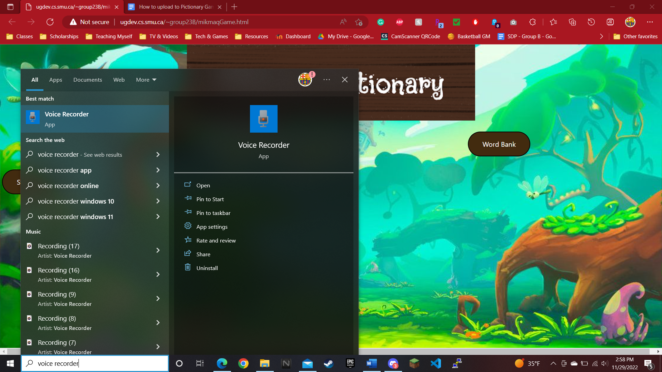

3). Click on the giant blue microphone button to begin recording audio.

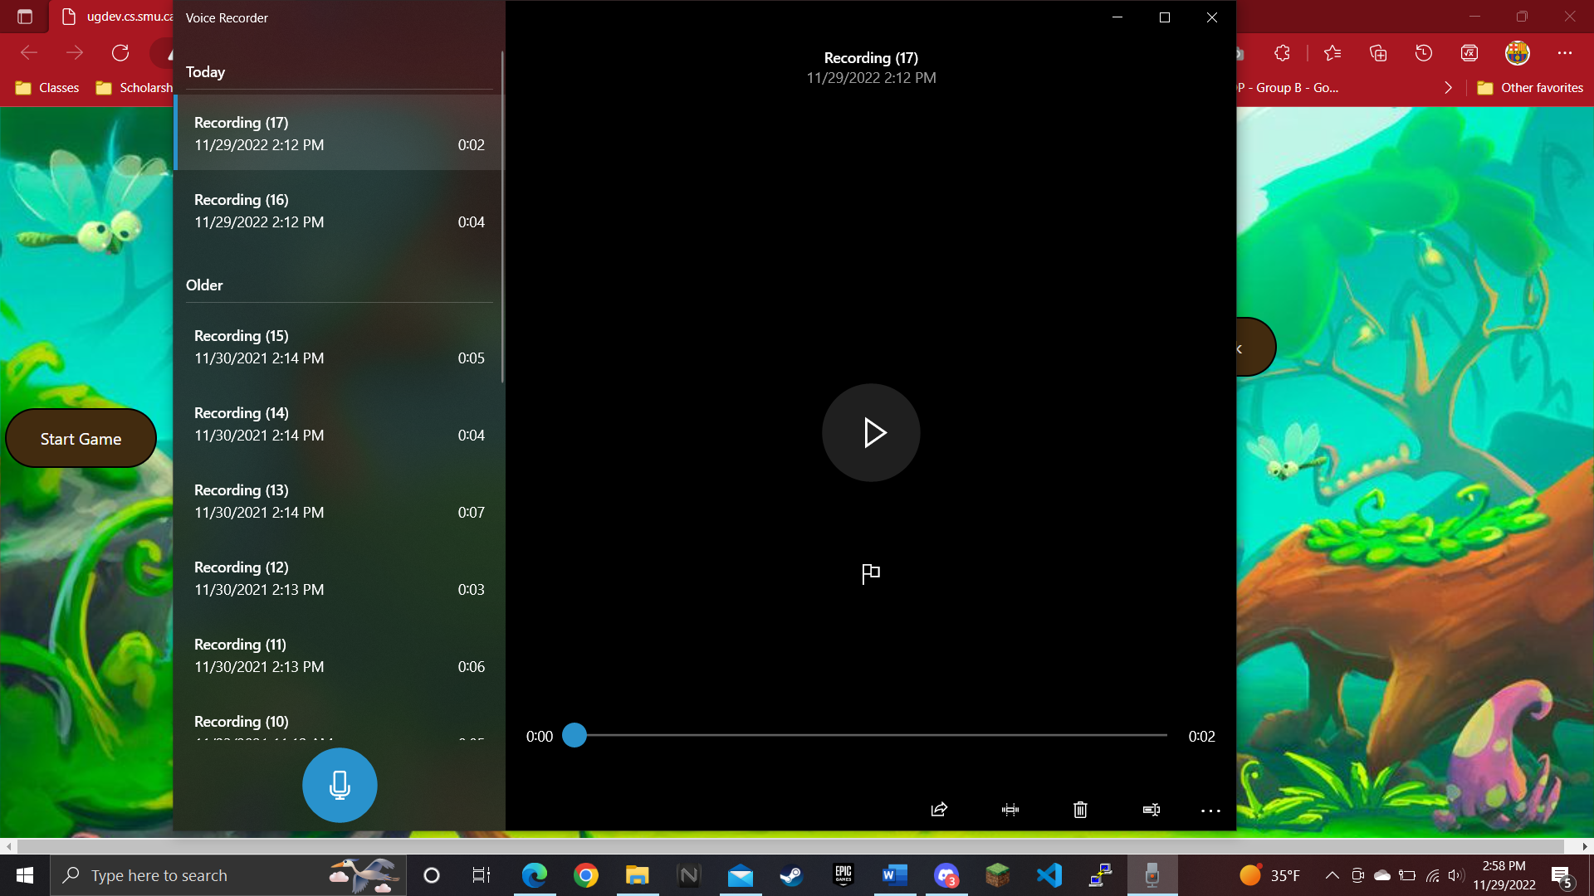

4). To Stop Recording click on the Stop button in the middle of the application.

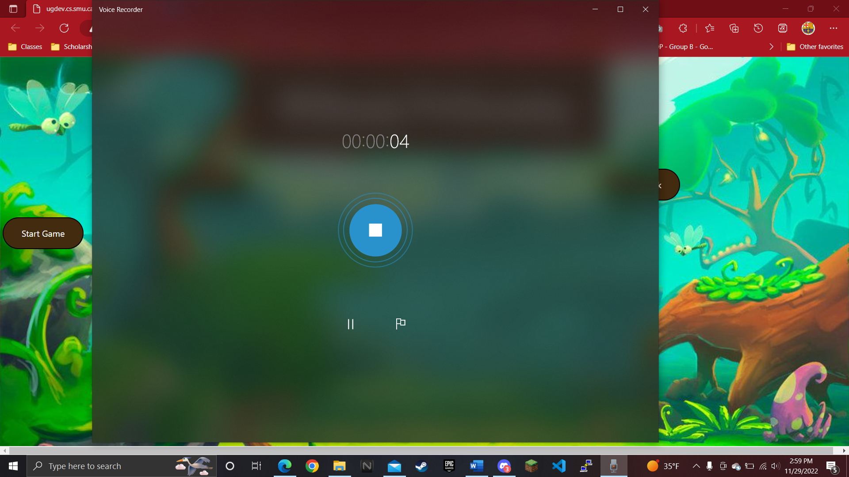

5). The Recording should be saved and ready to use

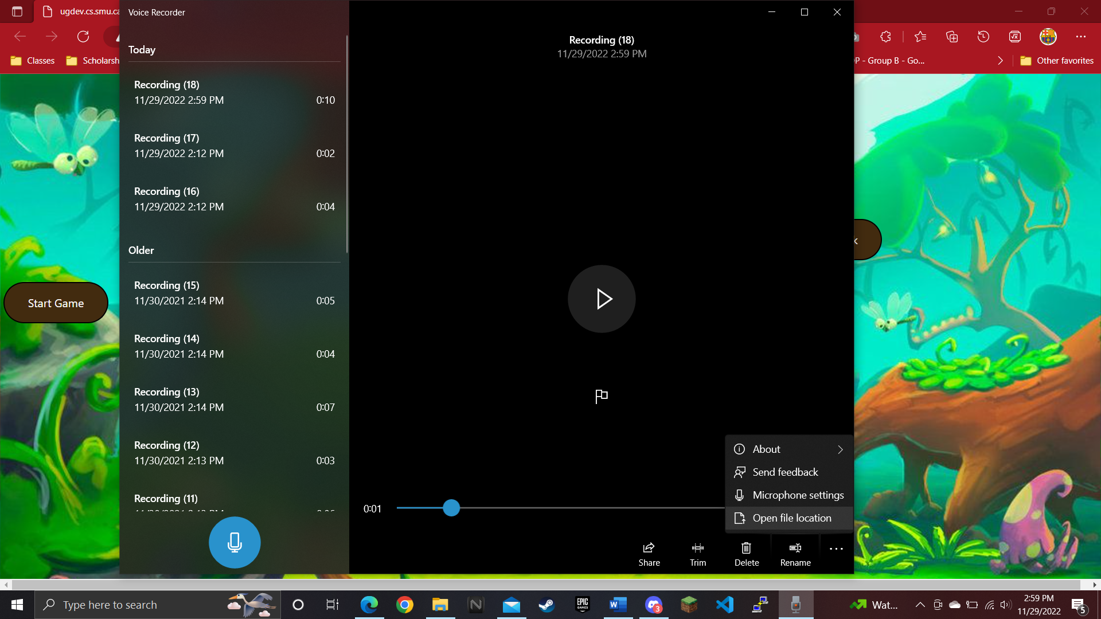

# Uploading on Apple OS (Ipads/Iphone/ect)

## Recording Audio

1. On your device, go to the app Voice Memos, the icon looks like the one circled below

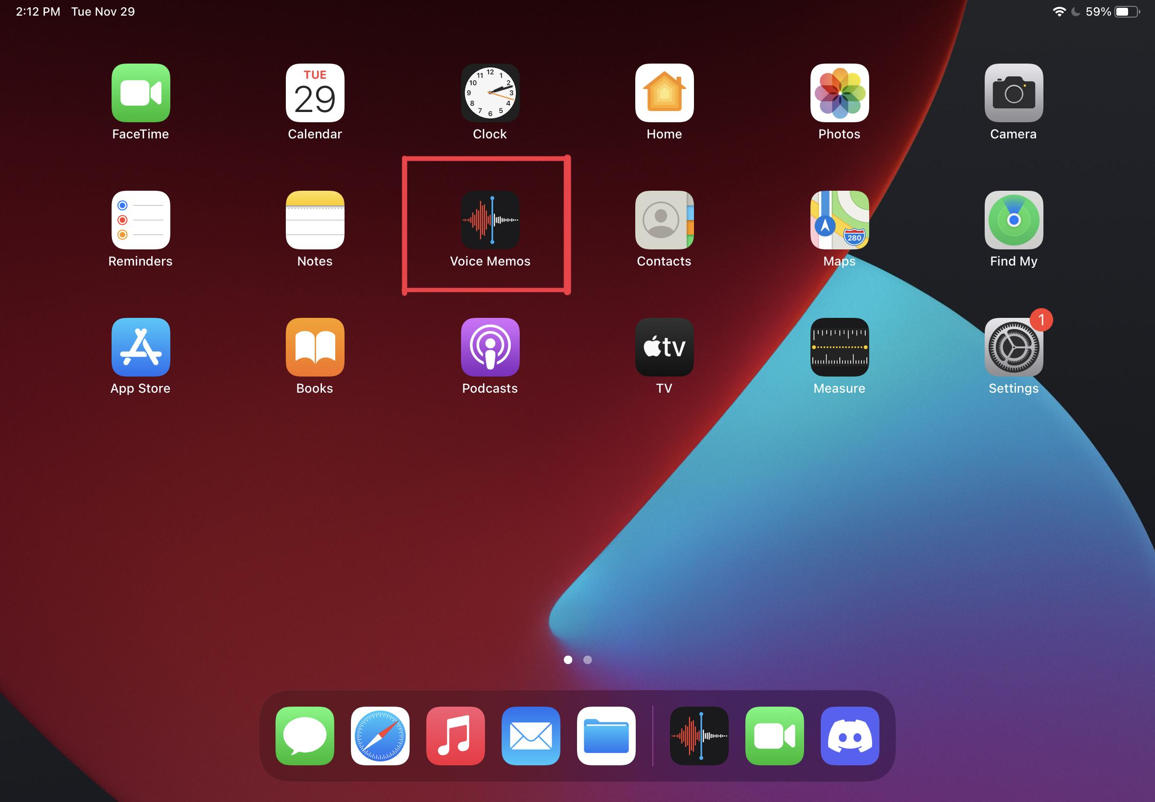

* 1. If you do not see the icon on your home screen, swipe down on the screen to bring up your search bar
  2. Search for the app “Voice Memos”

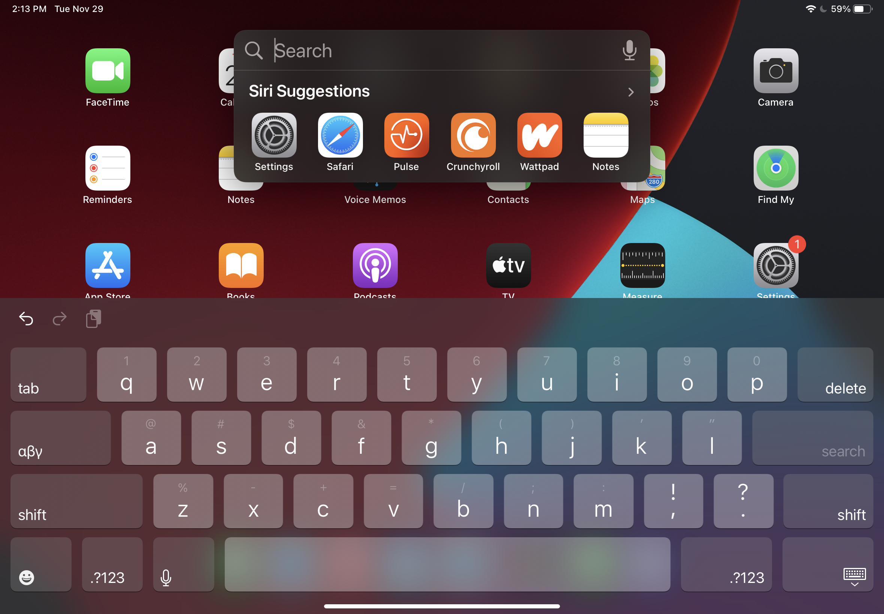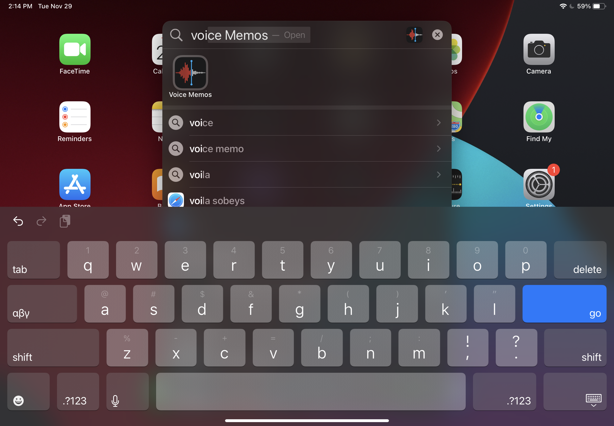

1. Once in the app it should look similar to this

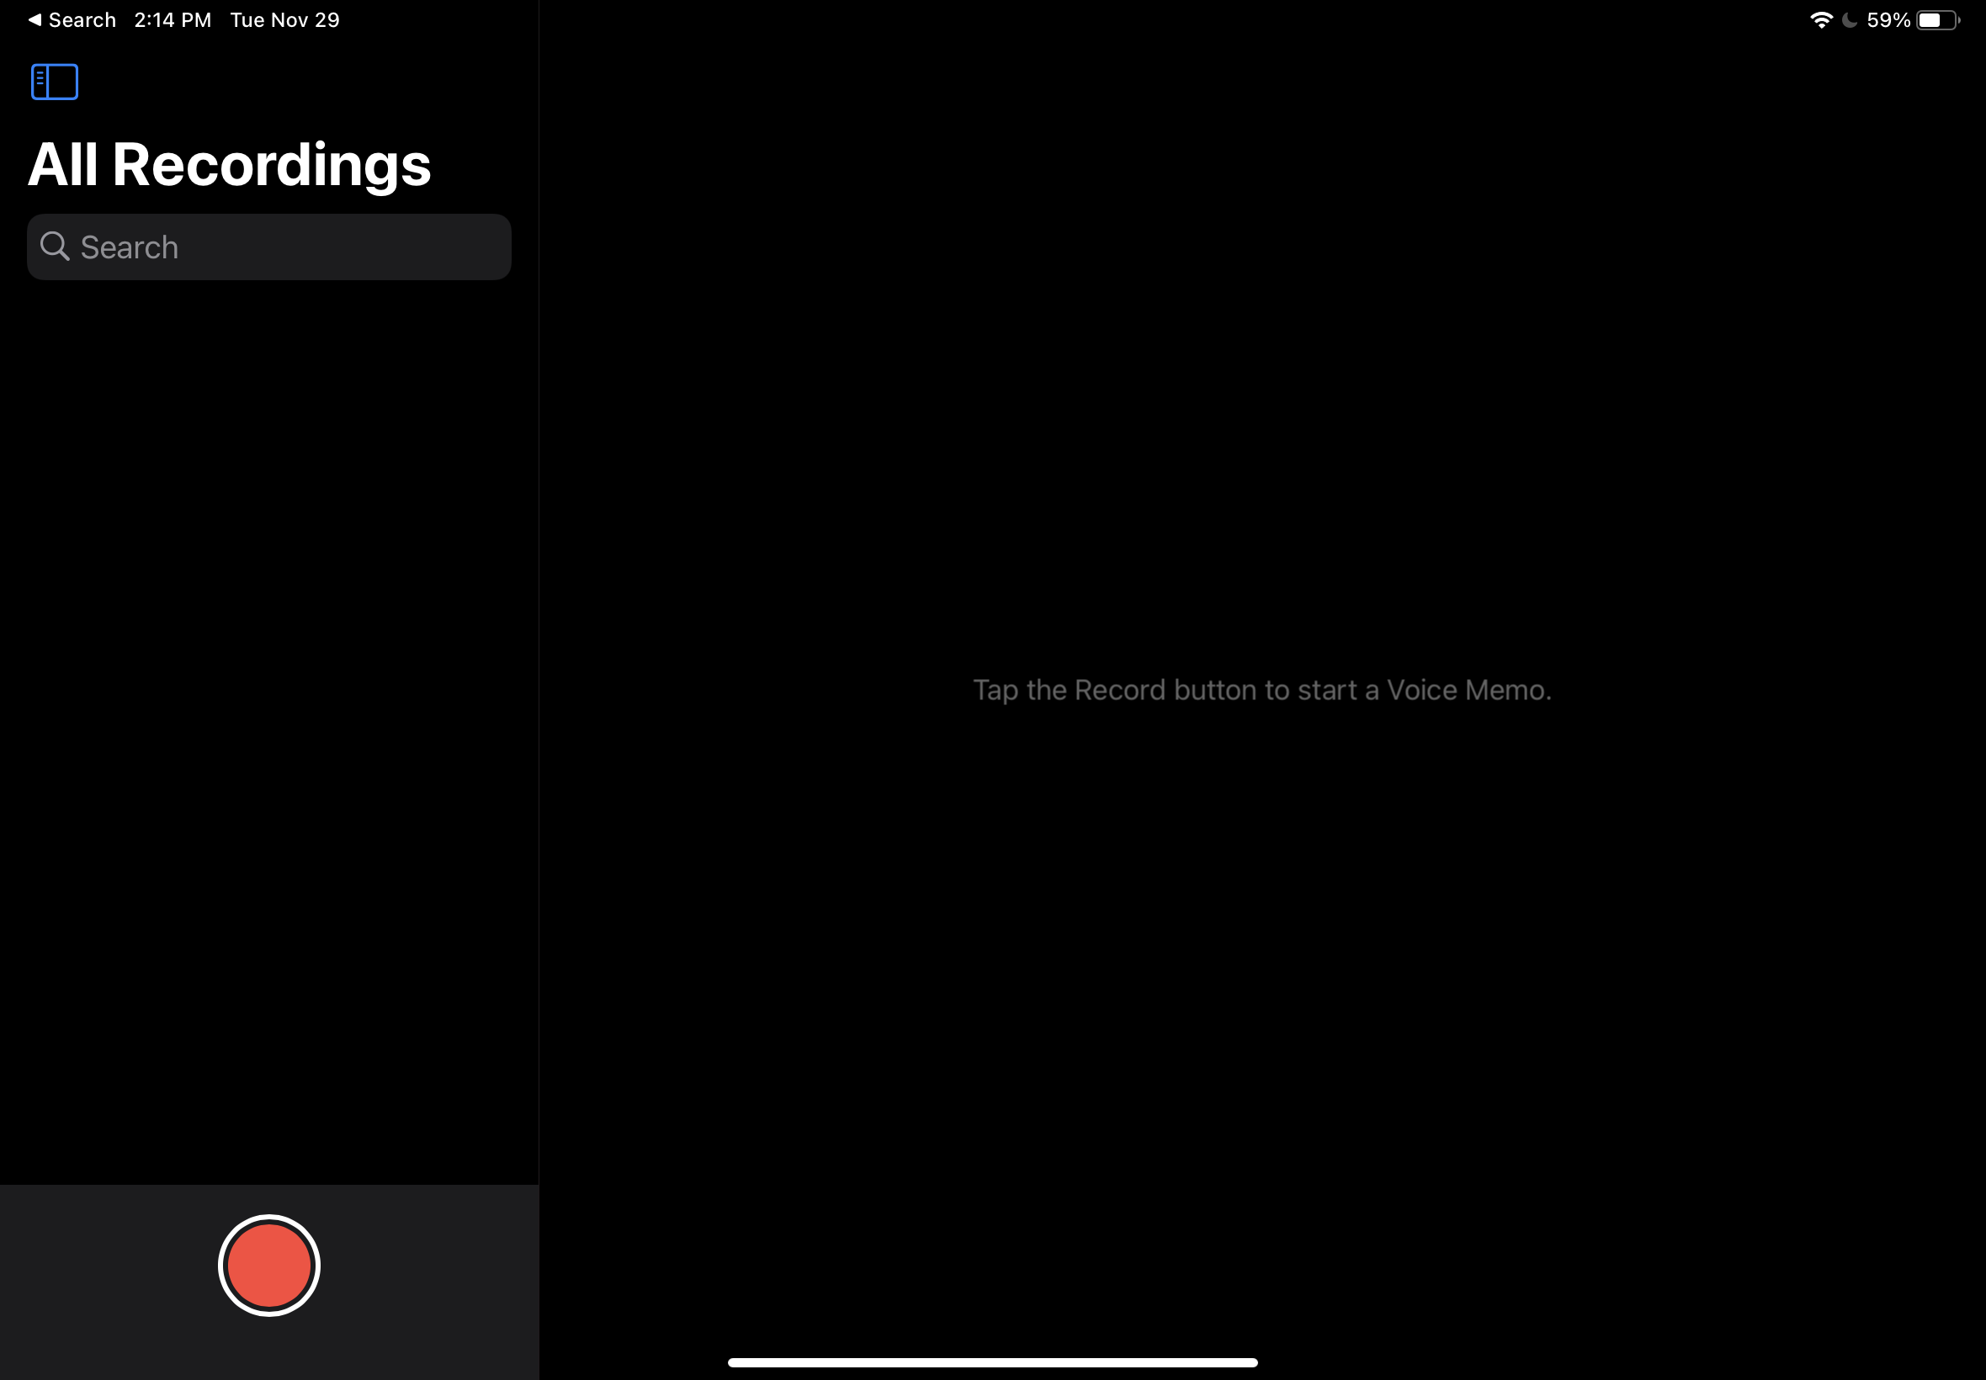

1. Click the record button to begin recording your audio
2. Once done You will see a default file name similar to the one here

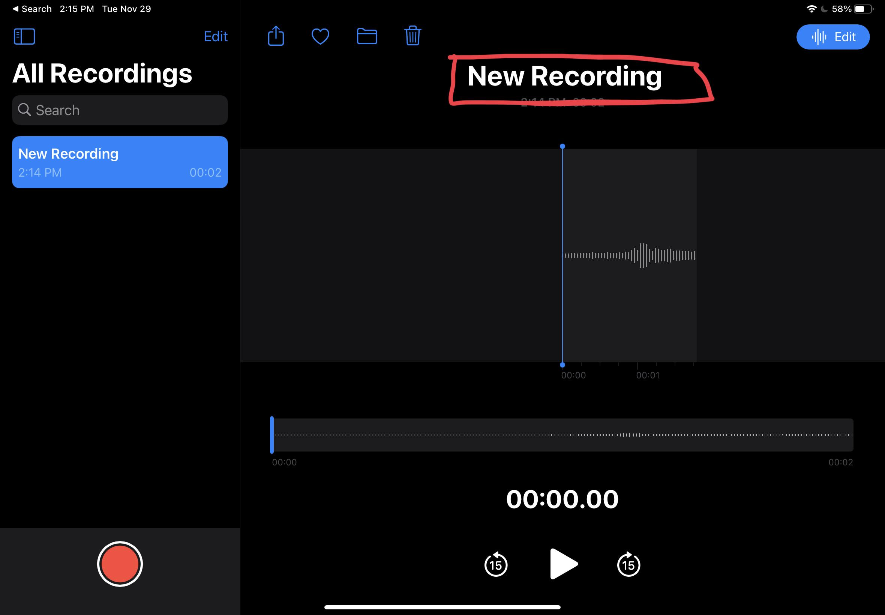

1. Click on the name to edit
2. Name must be made to be the vocab word, anything else and the server will reject it.
   1. Example: If the word you are adding is “aqq” the file name must be made to be aqq. In the below example I am uploading a file named “test”.
3. Next, click on the share button in the top left corner of the screen. The icon is shown below:

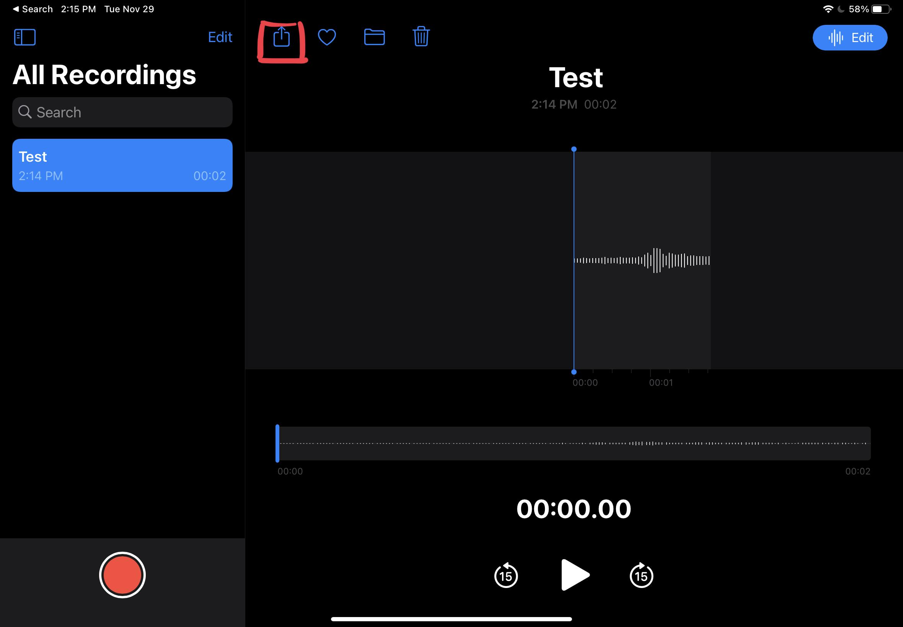

1. You may have to scroll to find this button, but next click the “Save to Files” button

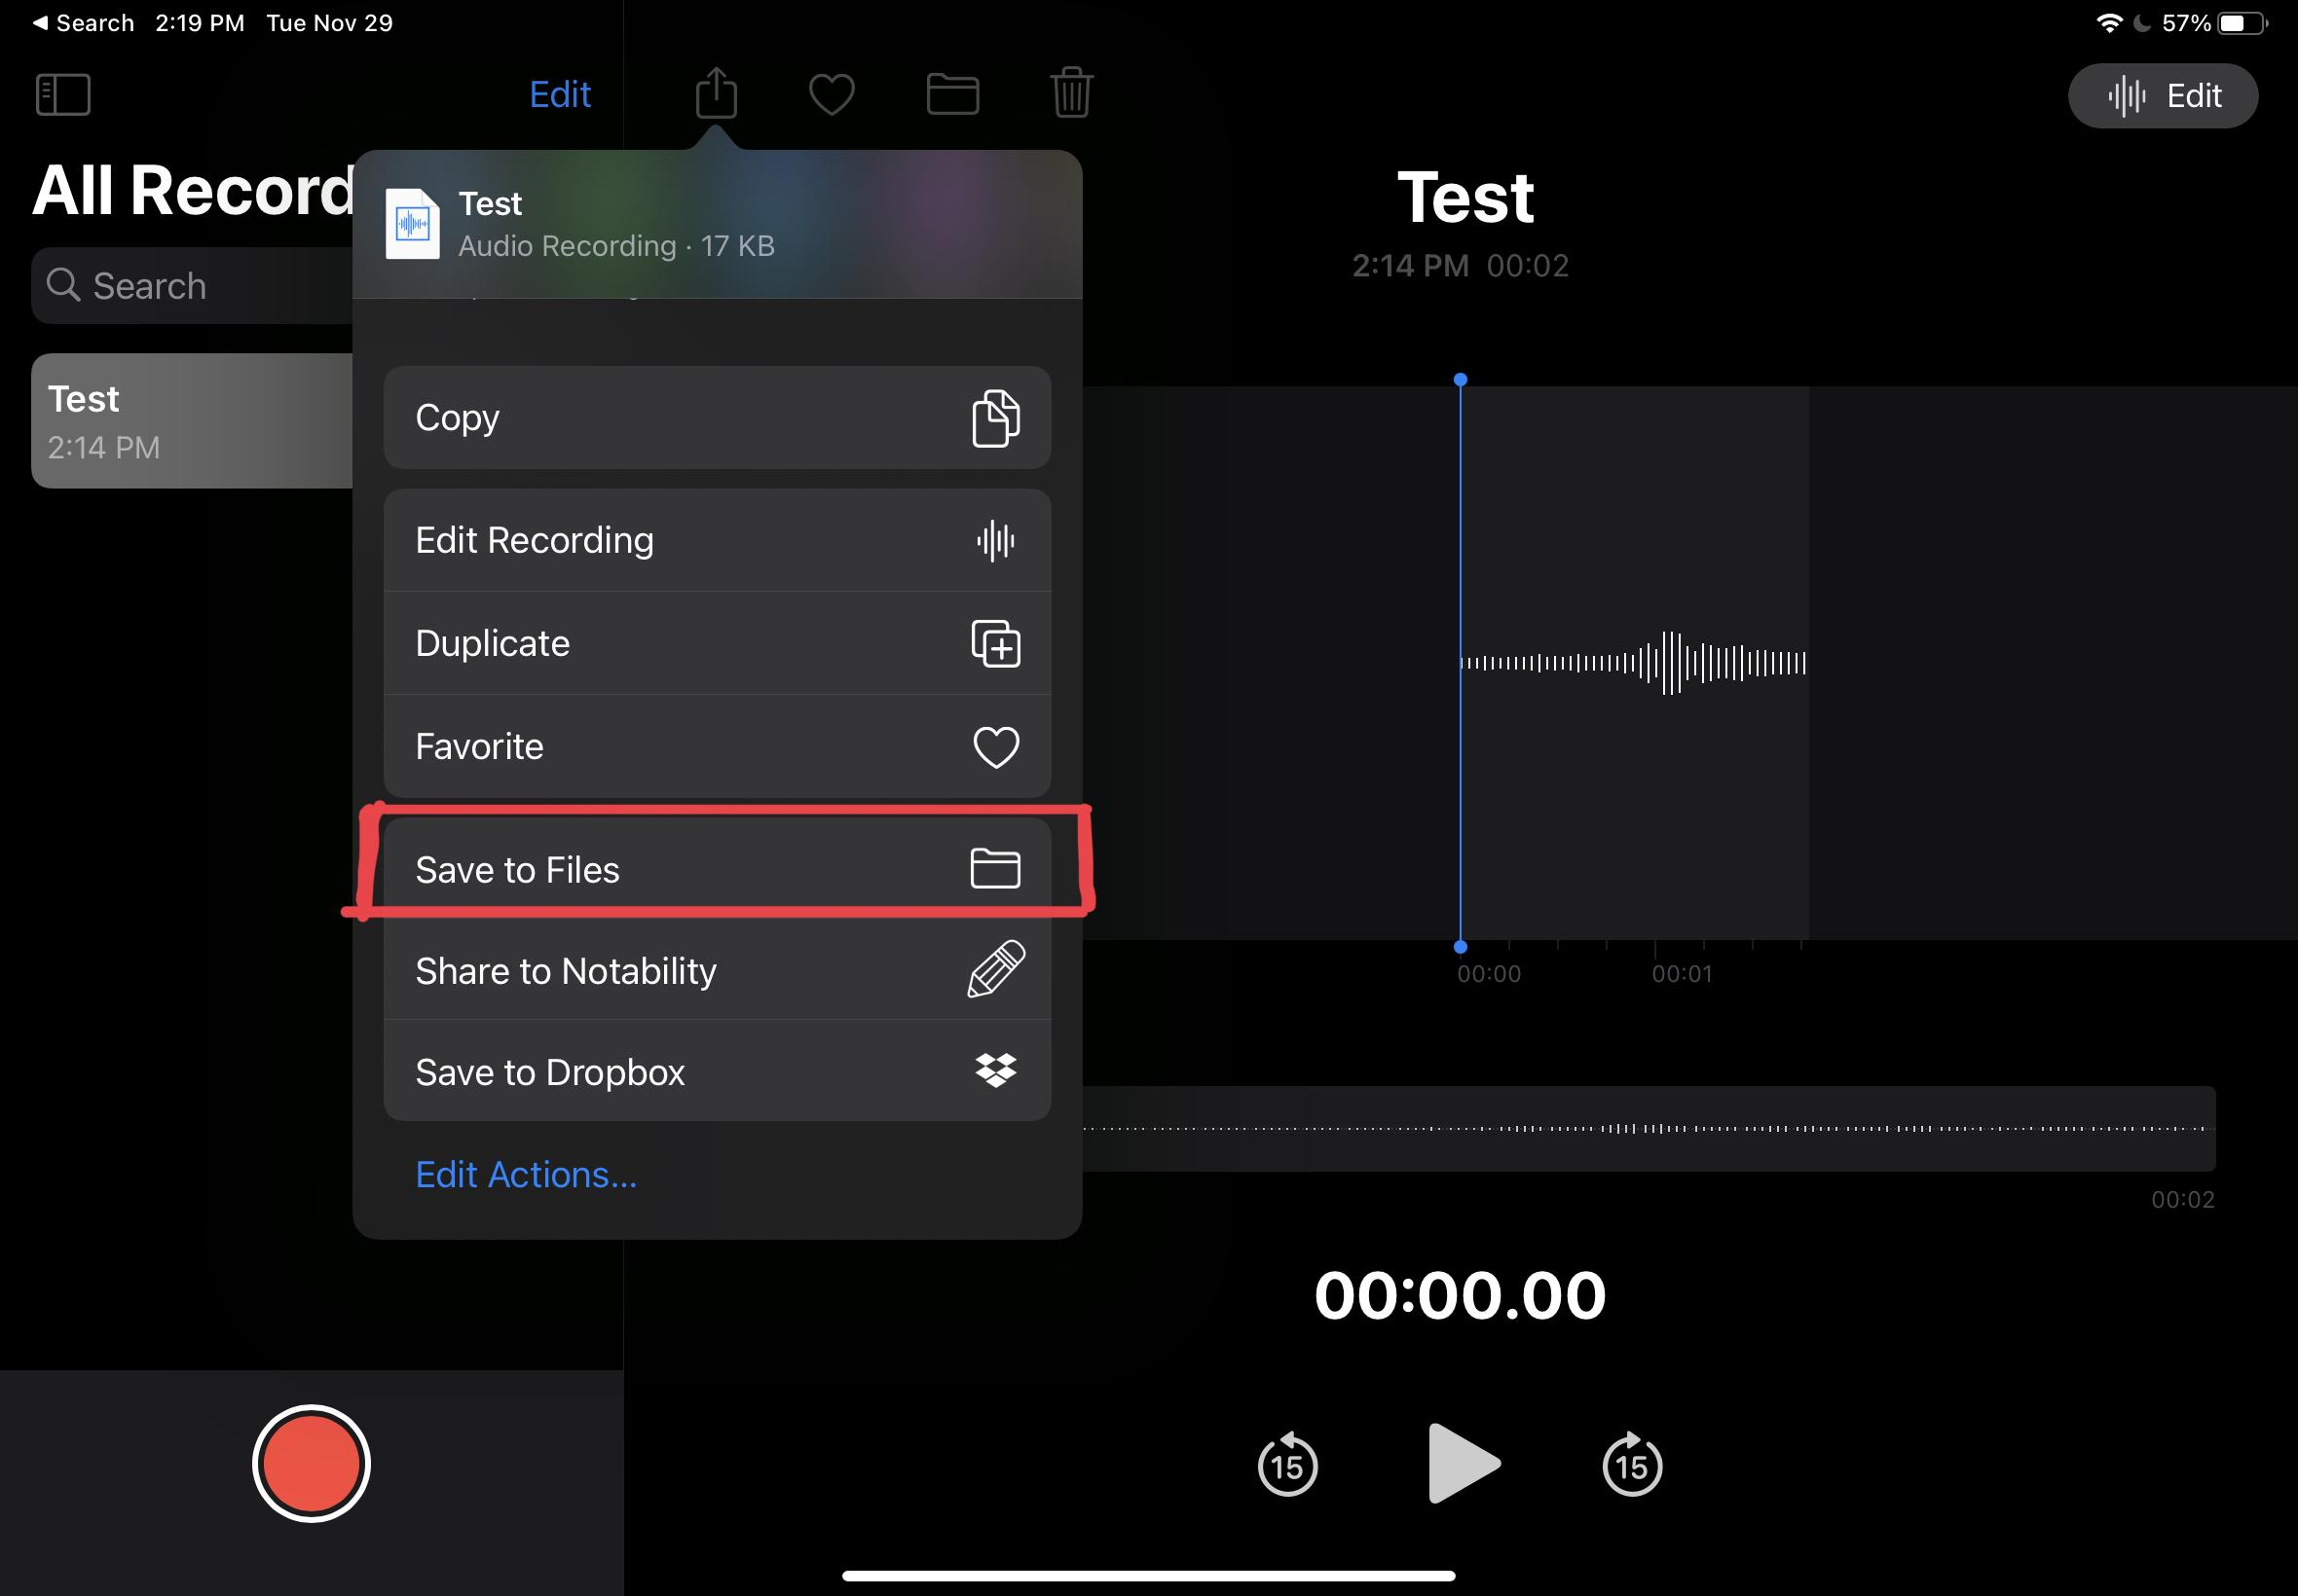

1. You will want to save the file somewhere you can easily find it. I recommend “On My Ipad” or “On my Iphone” for simplicity. You will also be able to see your file name to double check that you have followed the naming requirements.

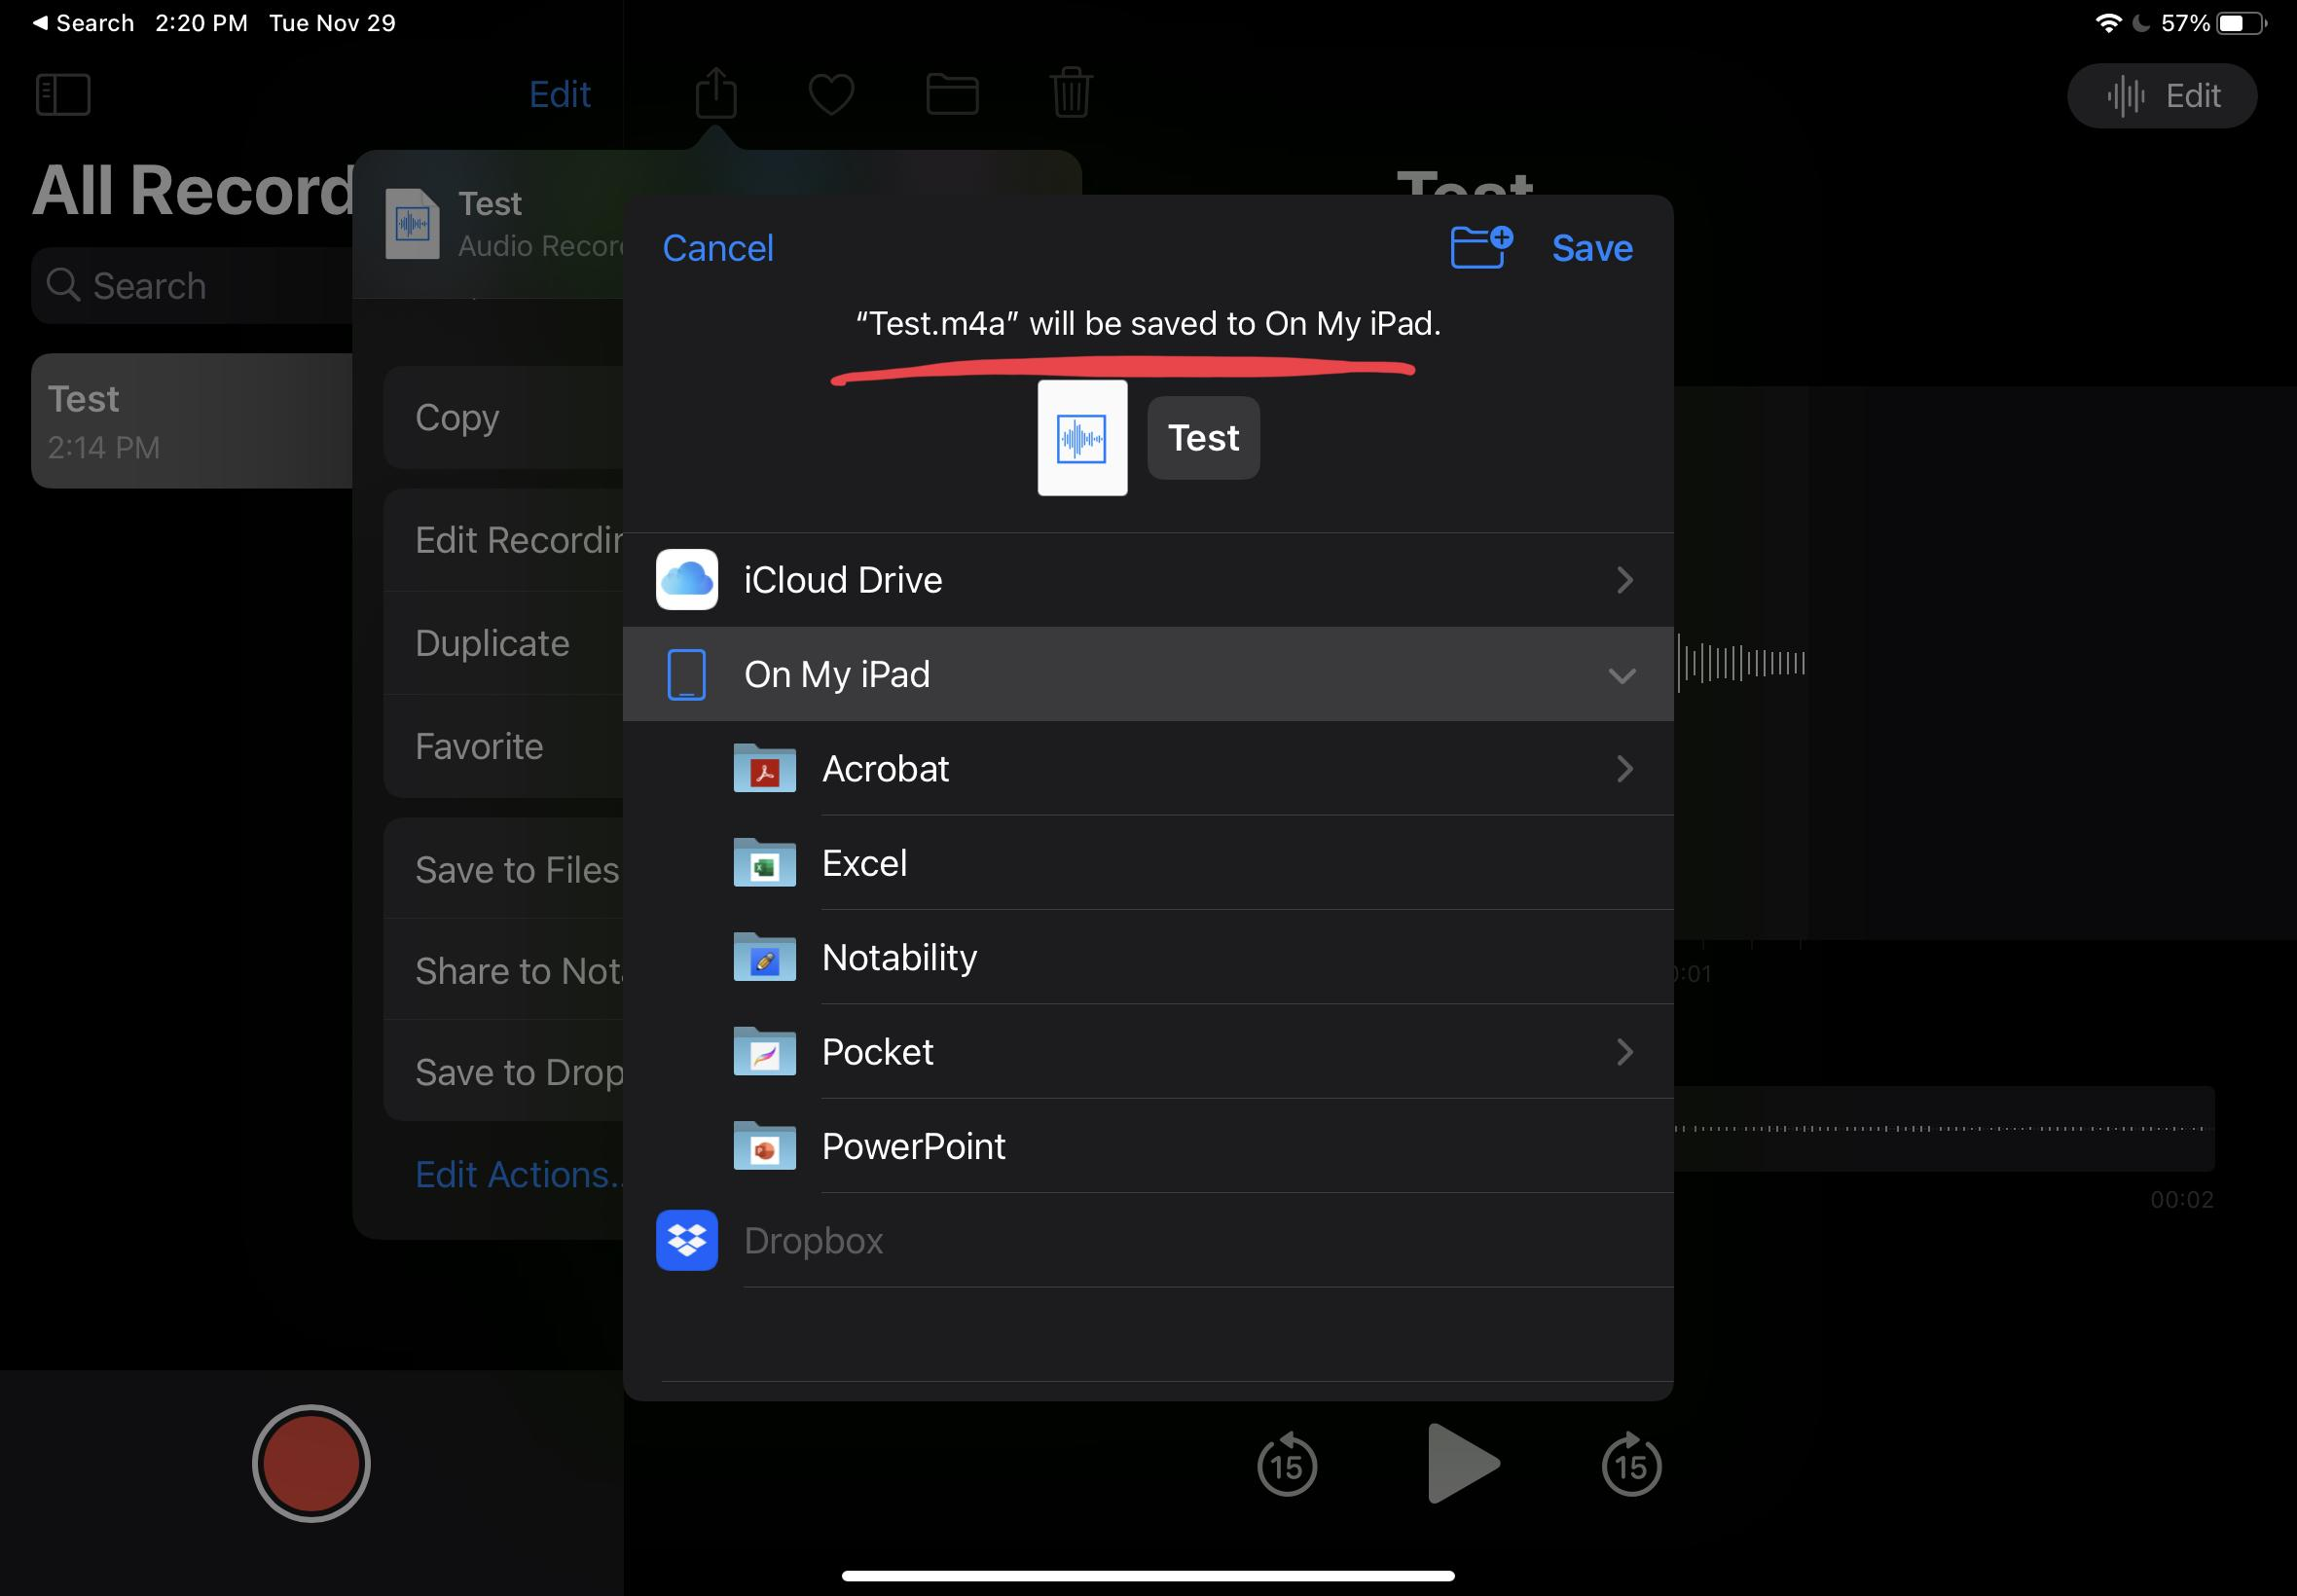

1. After the folder is selected, it will be highlighted to show that it is focused. Click the “Save” button in the top right corner.

## Finding images to use

1. Go to your favourite browsing app (Safari/Chrome/ect.)
2. Find an image you would like to use for the game. Once found, press and hold down on the image until the options appear as shown in the second figure below.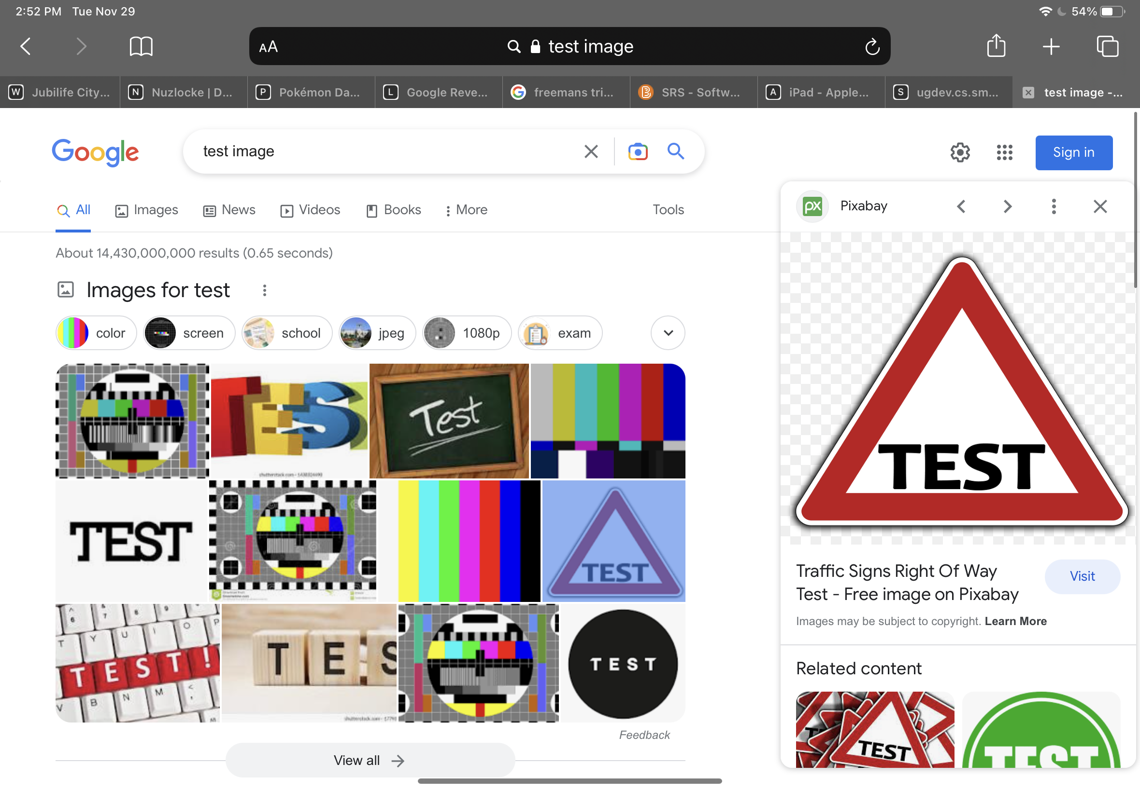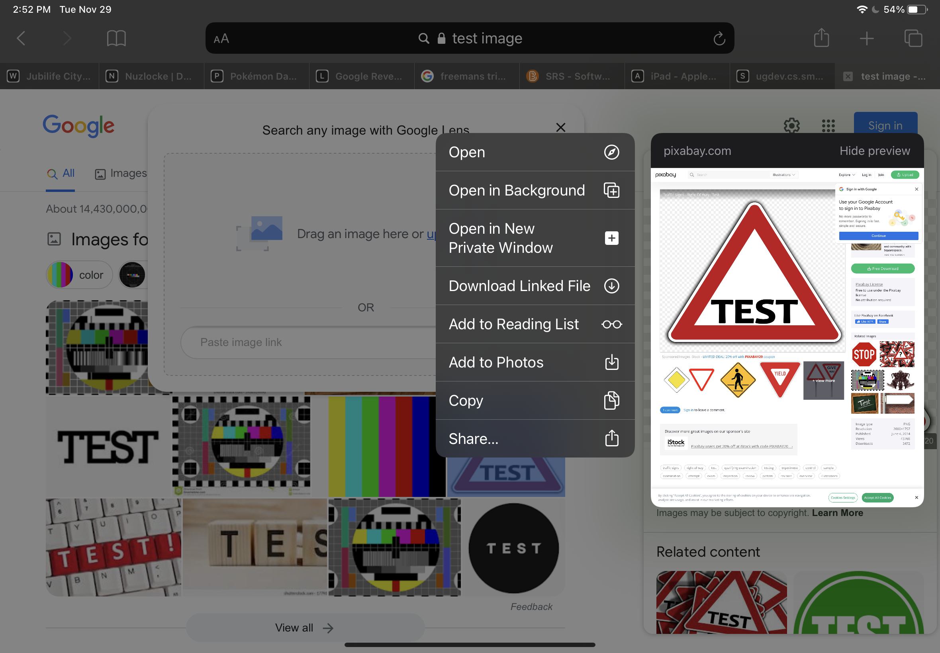
3. Press “Add to Photos”

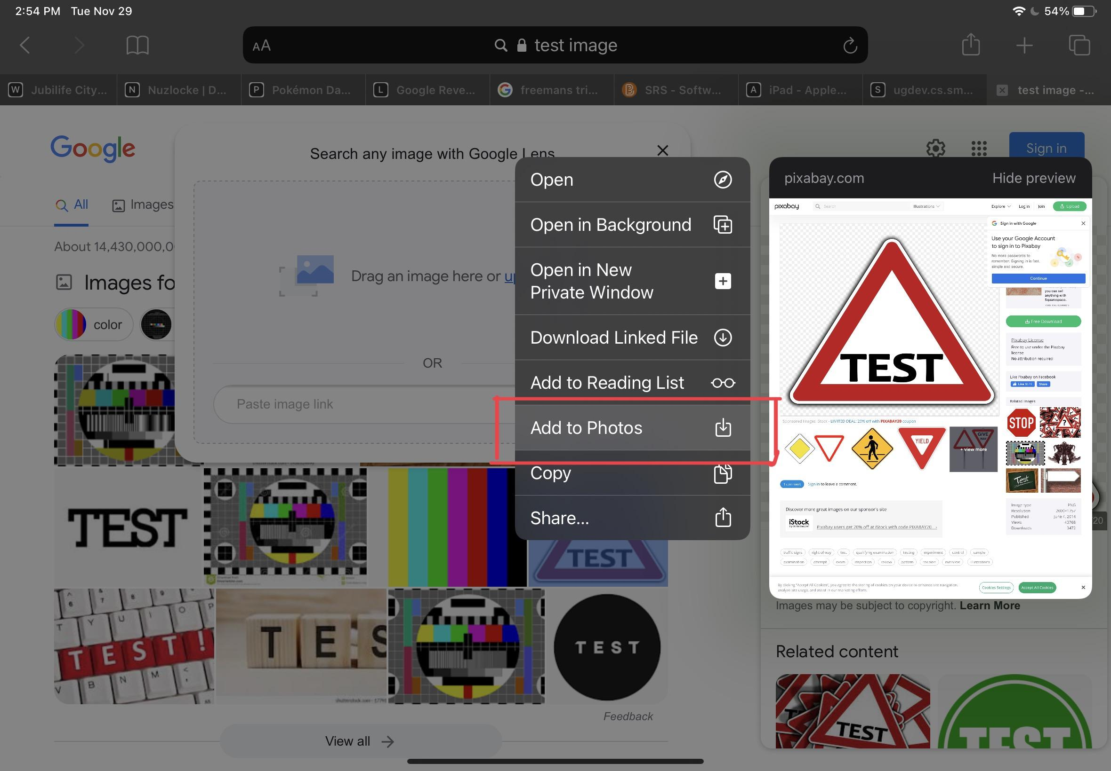

1. Navigate to your photos app
2. Click on your image and press the share button in the top right corner of the screen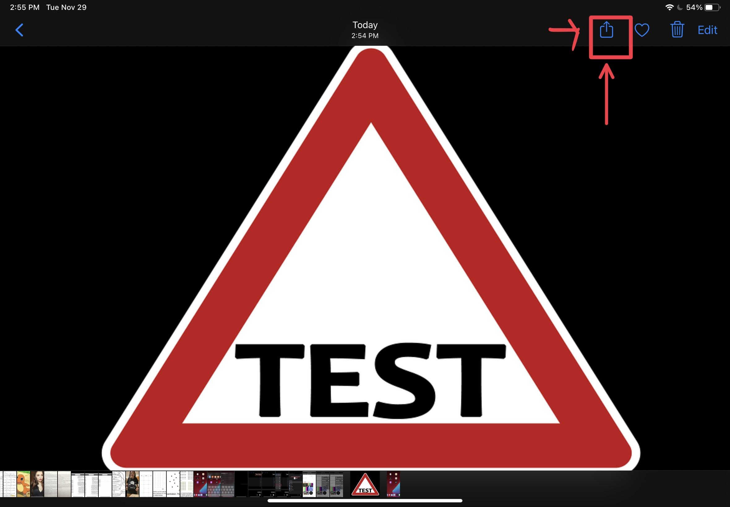
3. Click “Save to Files”

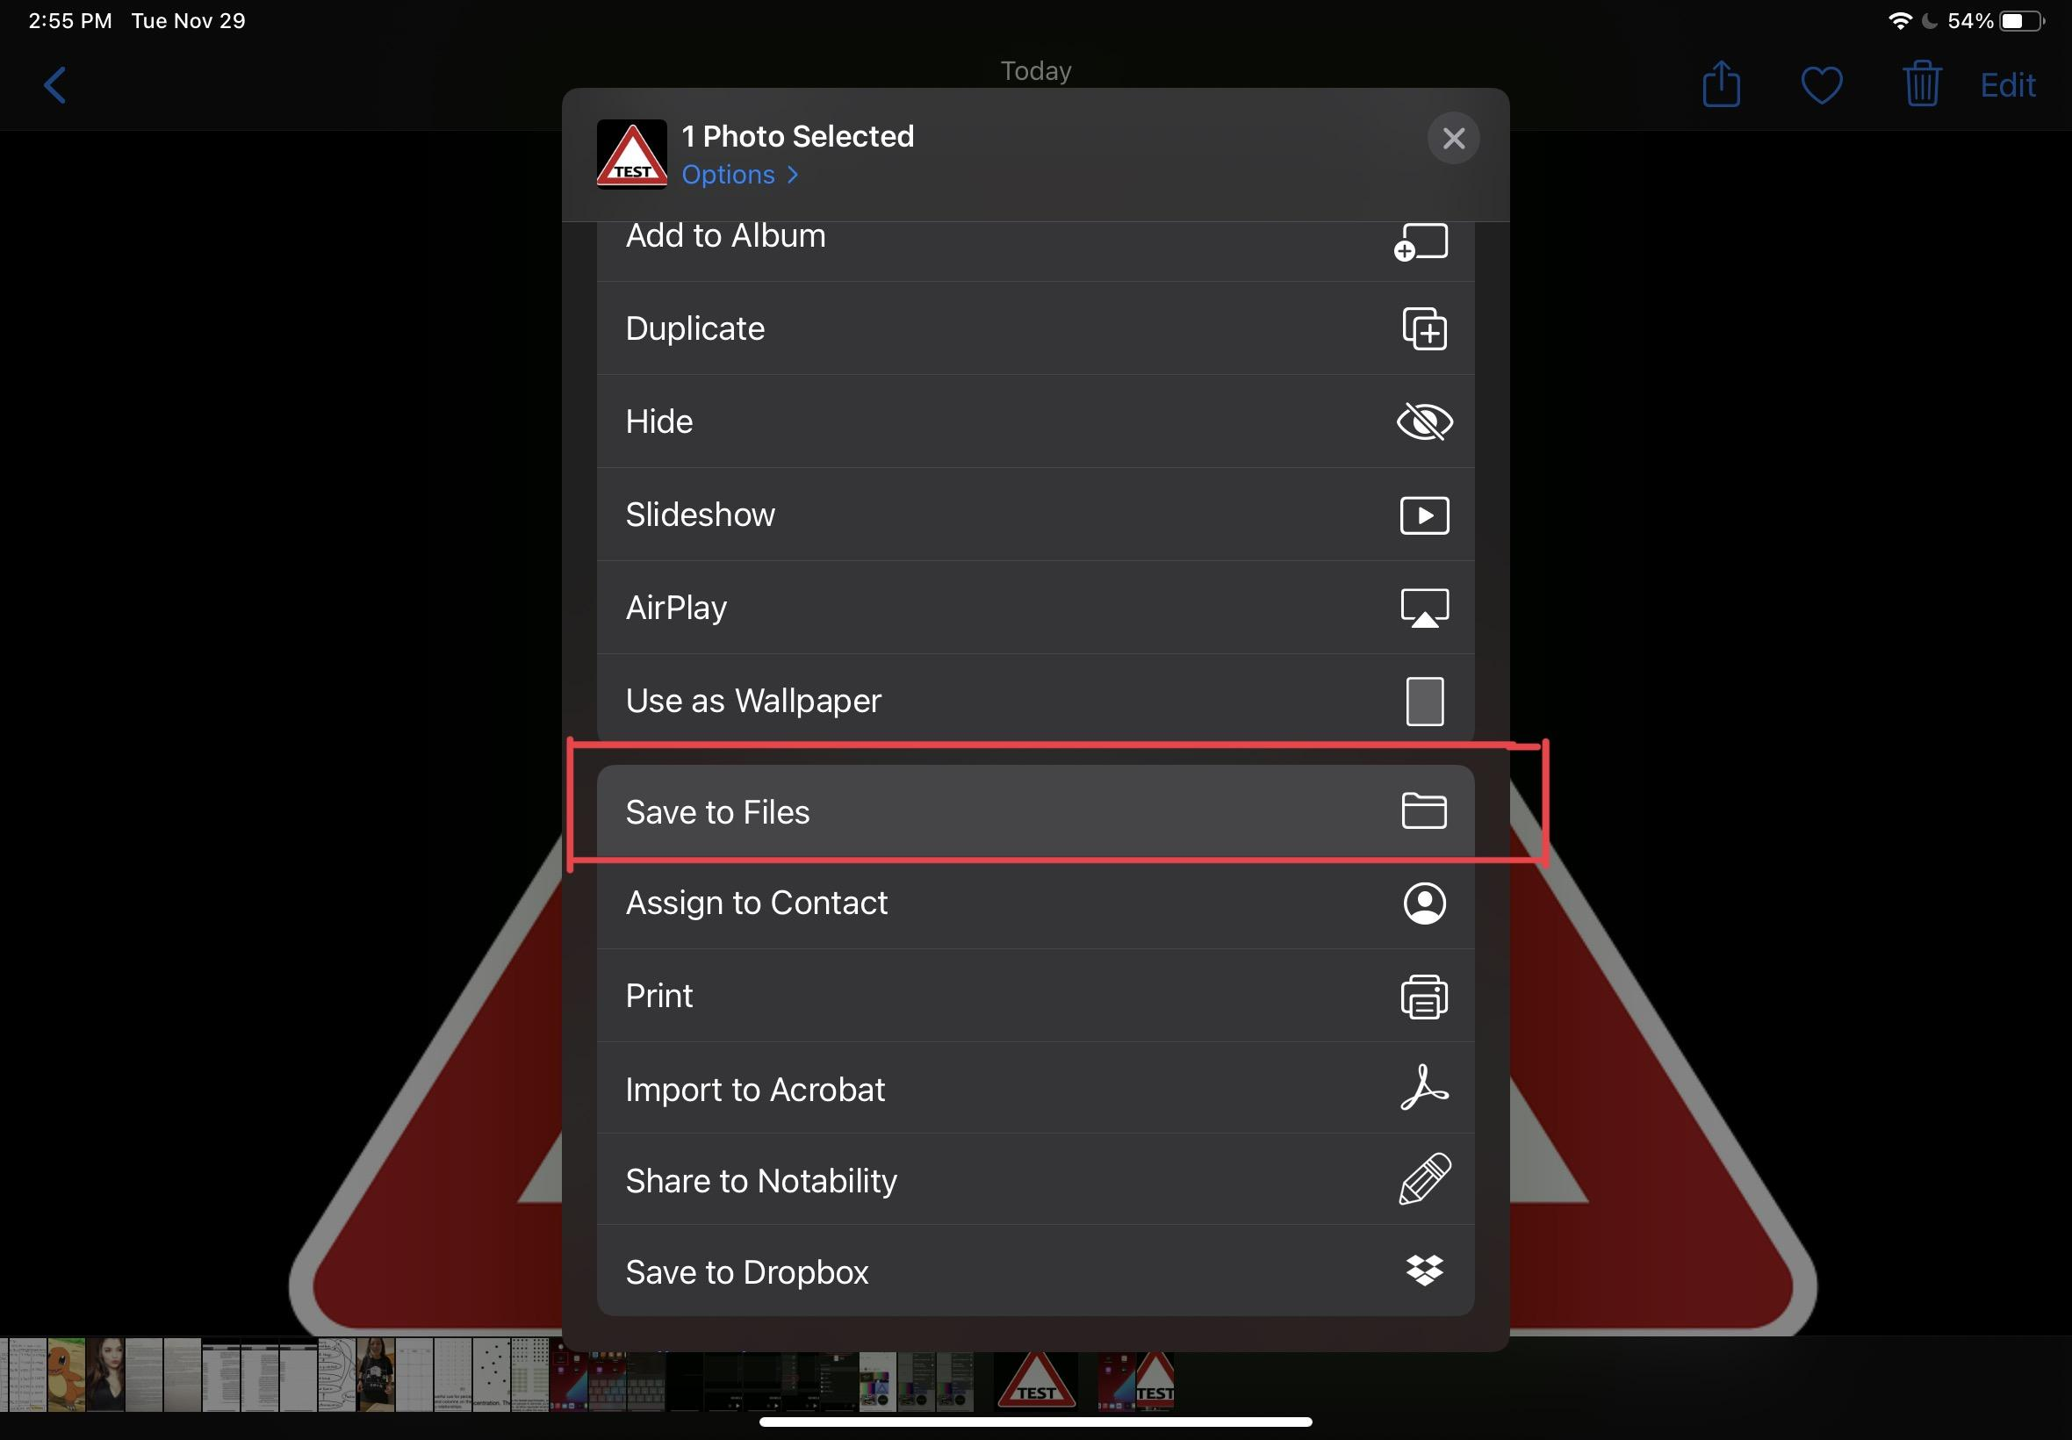

1. You will see the image has been named some default name maybe similar to this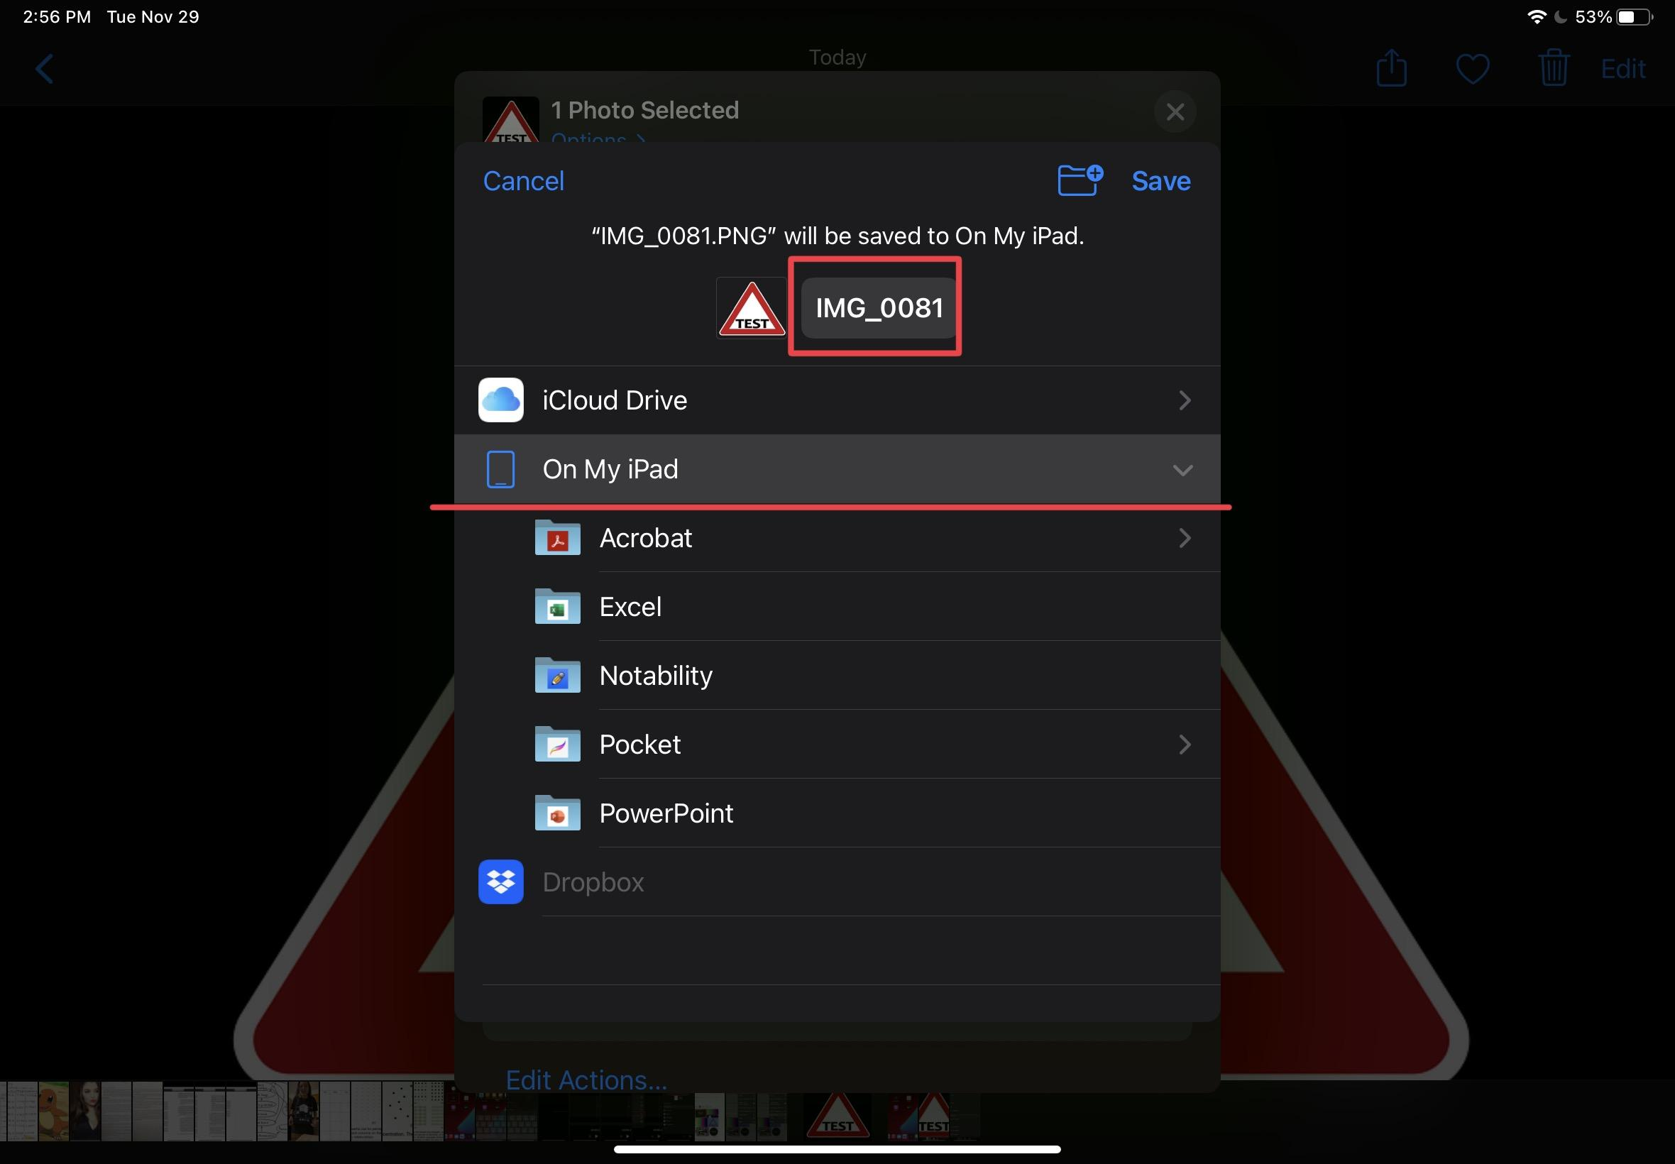
2. Press the name to edit it.
3. It is crucial that the image name is the same as the audio name.
   1. Example, my audio file was named “Test” so my image file is named “Test” as well

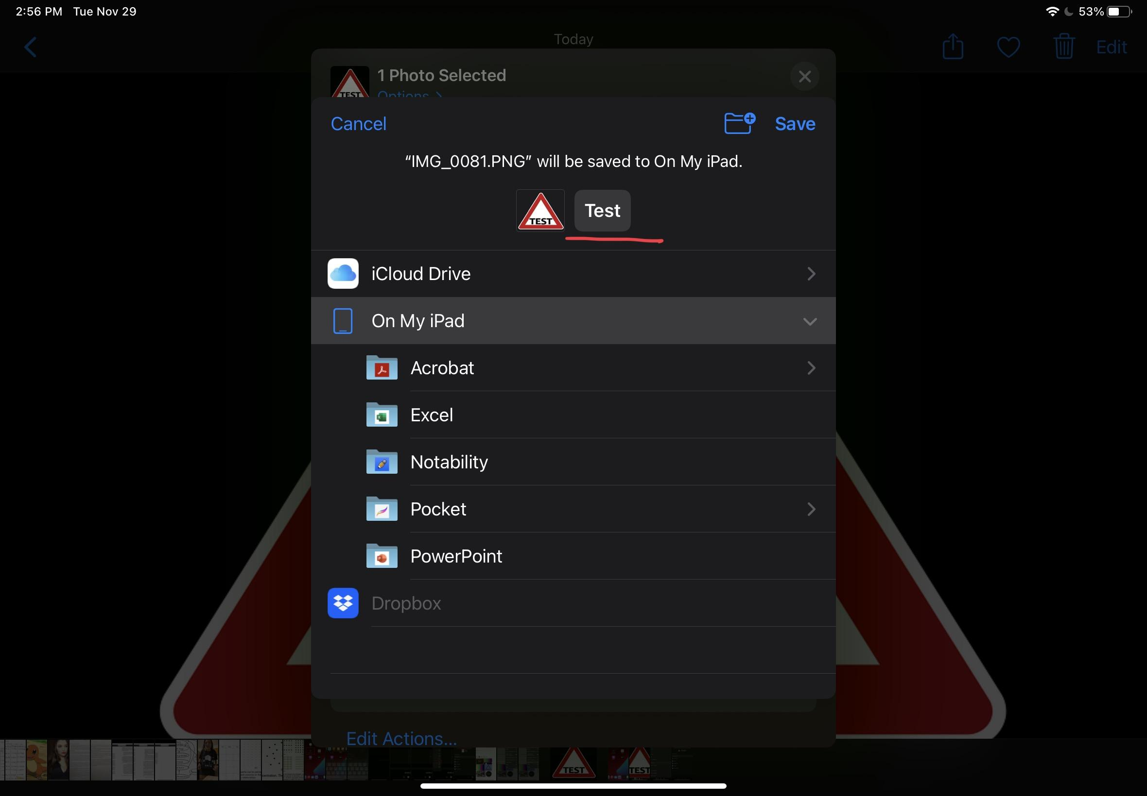

1. Save the file to somewhere you can easily locate, I recommend “On my IPad” or “On my Iphone”.

## Uploading to site

1. On Safari or whatever browsing app of your choice (chrome, etc), go to the site: [ugdev.cs.smu.ca/~group23B/mikmaqGame.html](http://ugdev.cs.smu.ca/~group23B/mikmaqGame.html)
2. Click the start game button to enter a game
3. Click the button in the top left corner of the screen with the lock icon
4. In the text bar, enter your password, at this time the password is “only me”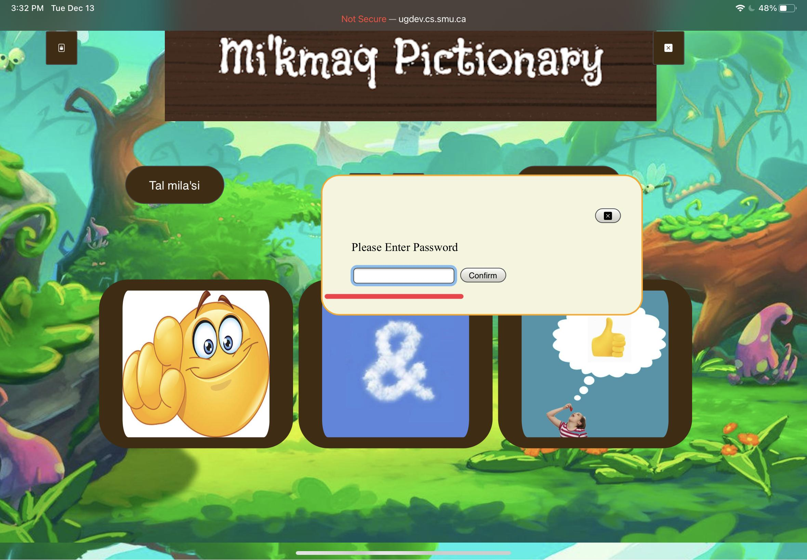
5. Click the first “Upload File” button. This is for the image file. Next you need to click the “Browse” button and navigate through your files to your saved image.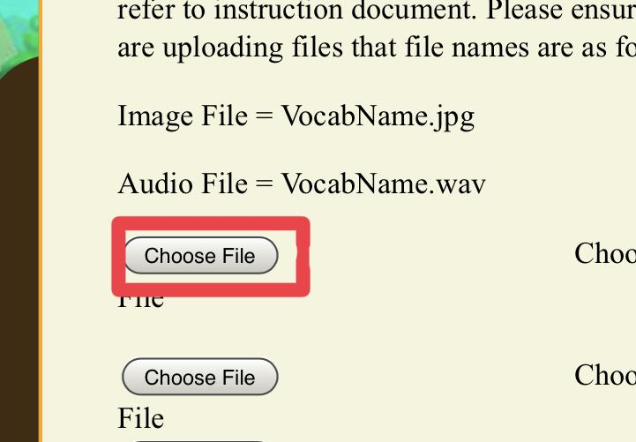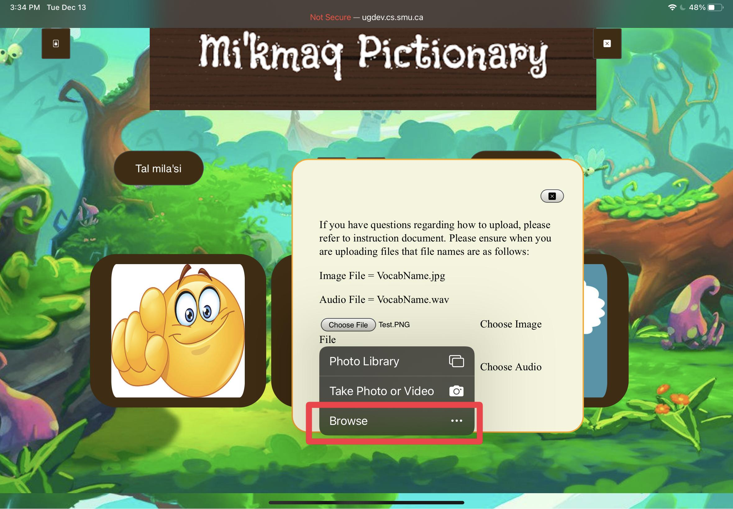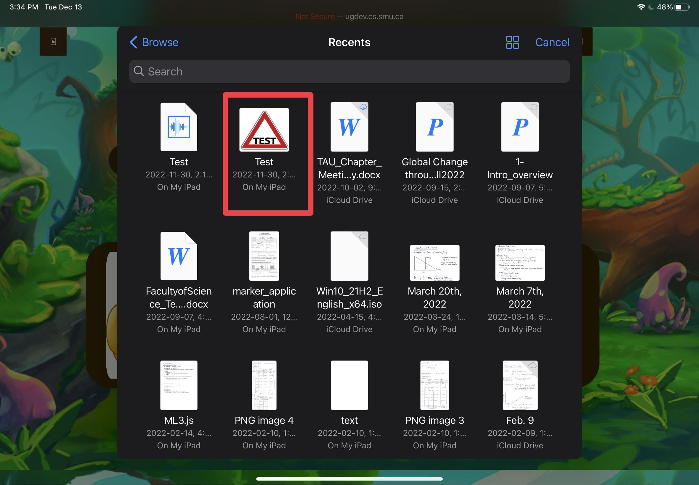
6. Click the second “Upload File” button. This is for the audio file. You can see the name for your image file as well as it now appears beside the upload image file button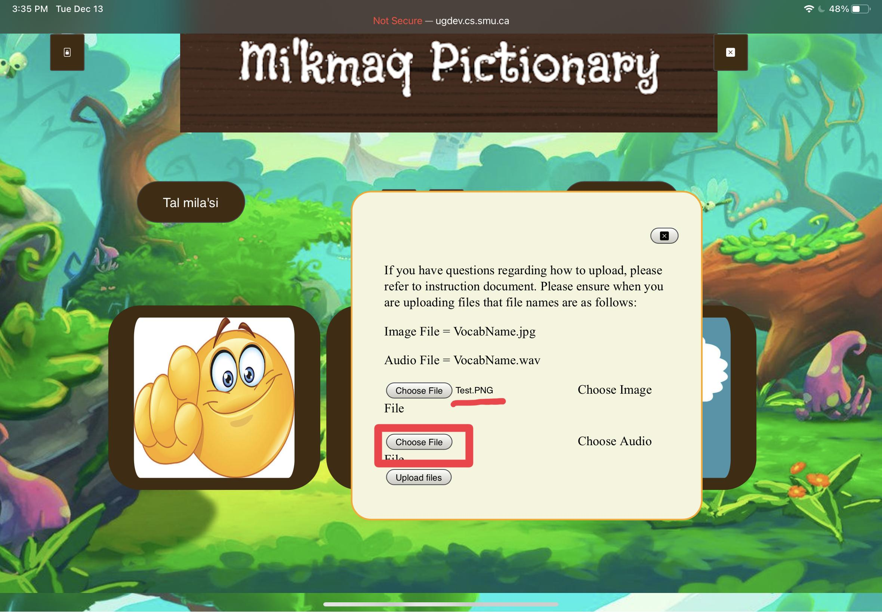
7. Once again you want to click the “Browse” button then navigate to your saved audio file.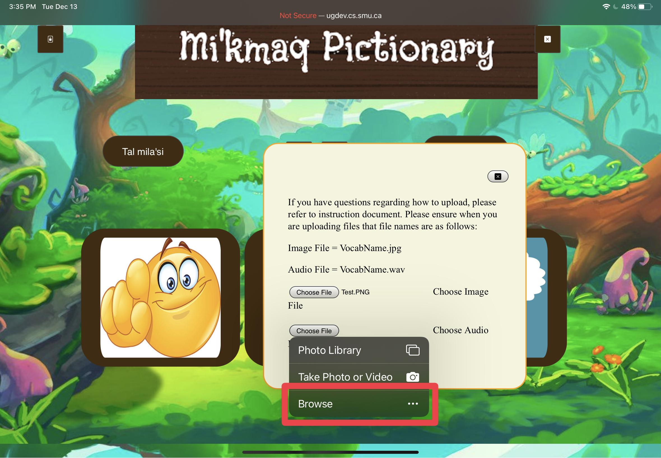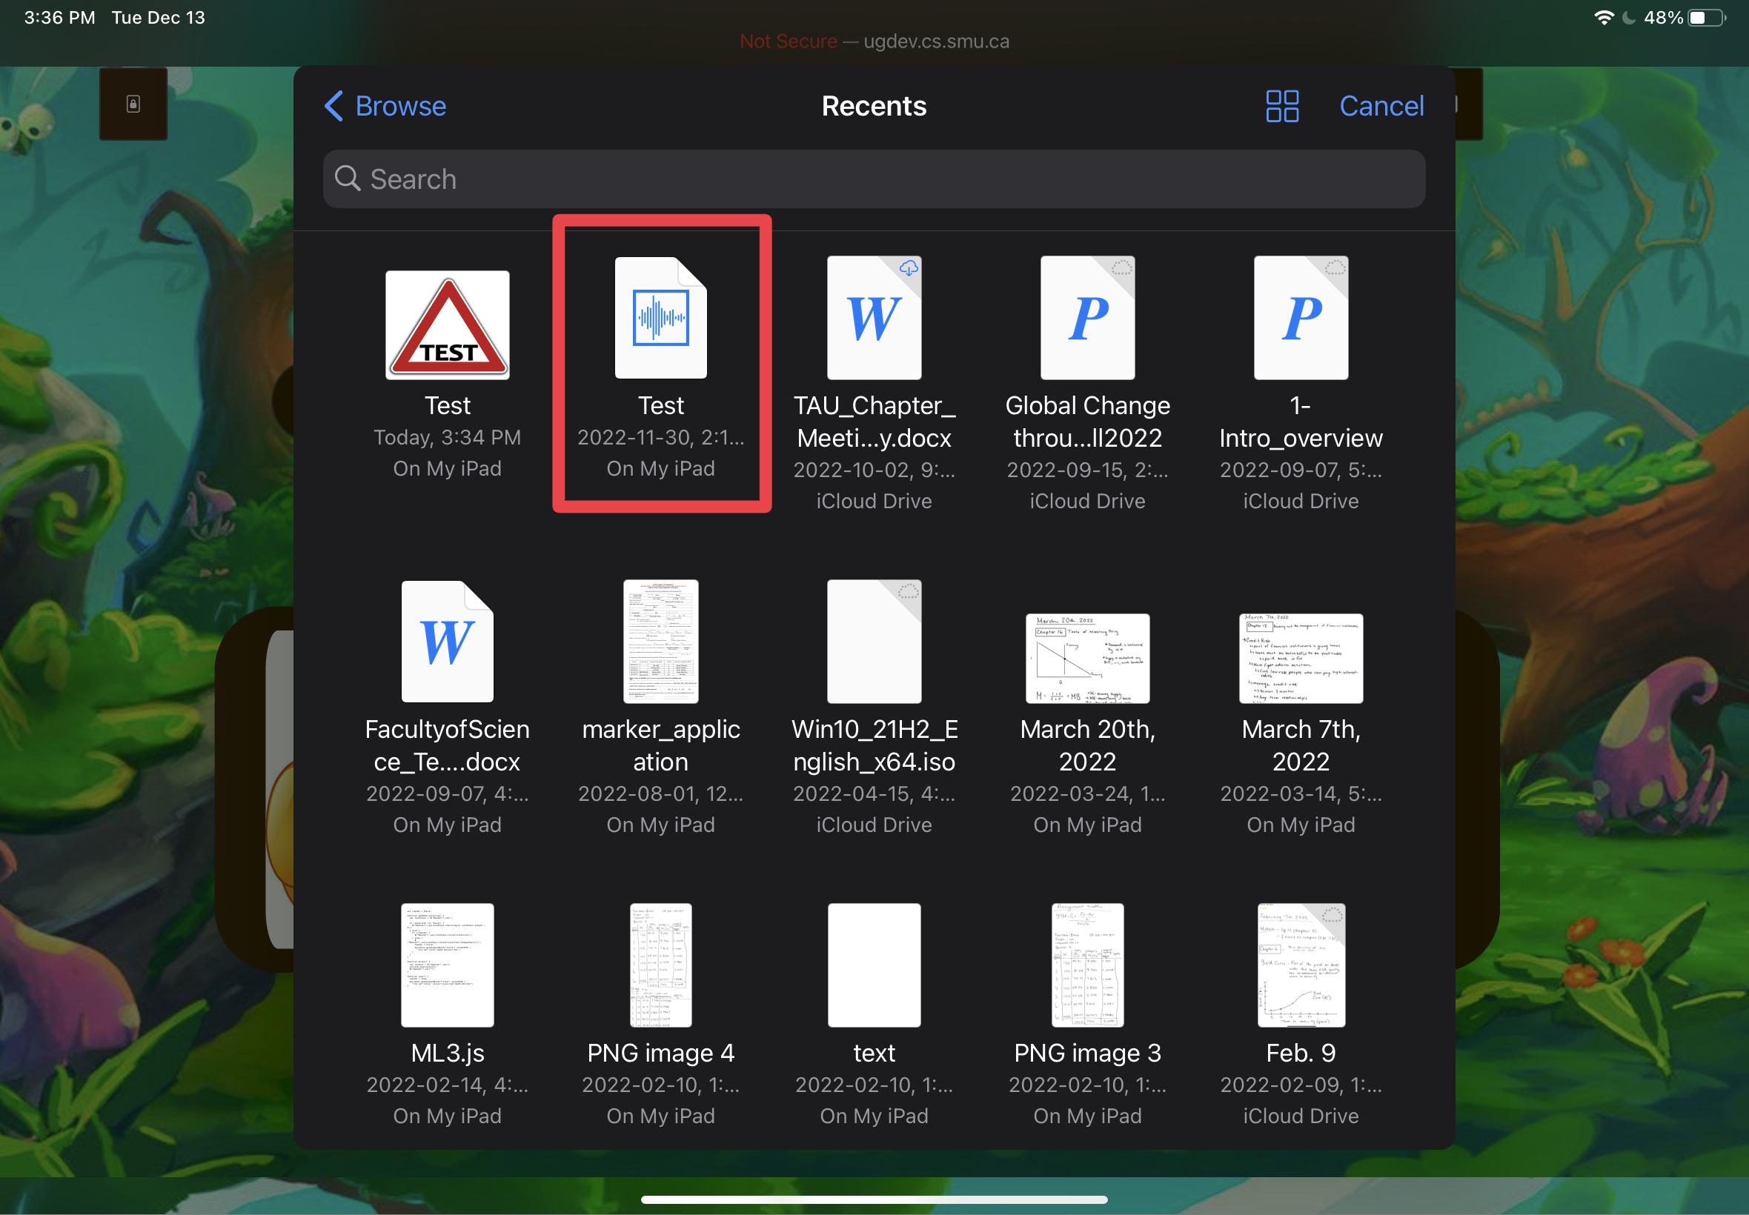
8. Click the Upload button to submit a form to add these files to the site. You can confirm the names of your files beside the upload buttons before making your final submission.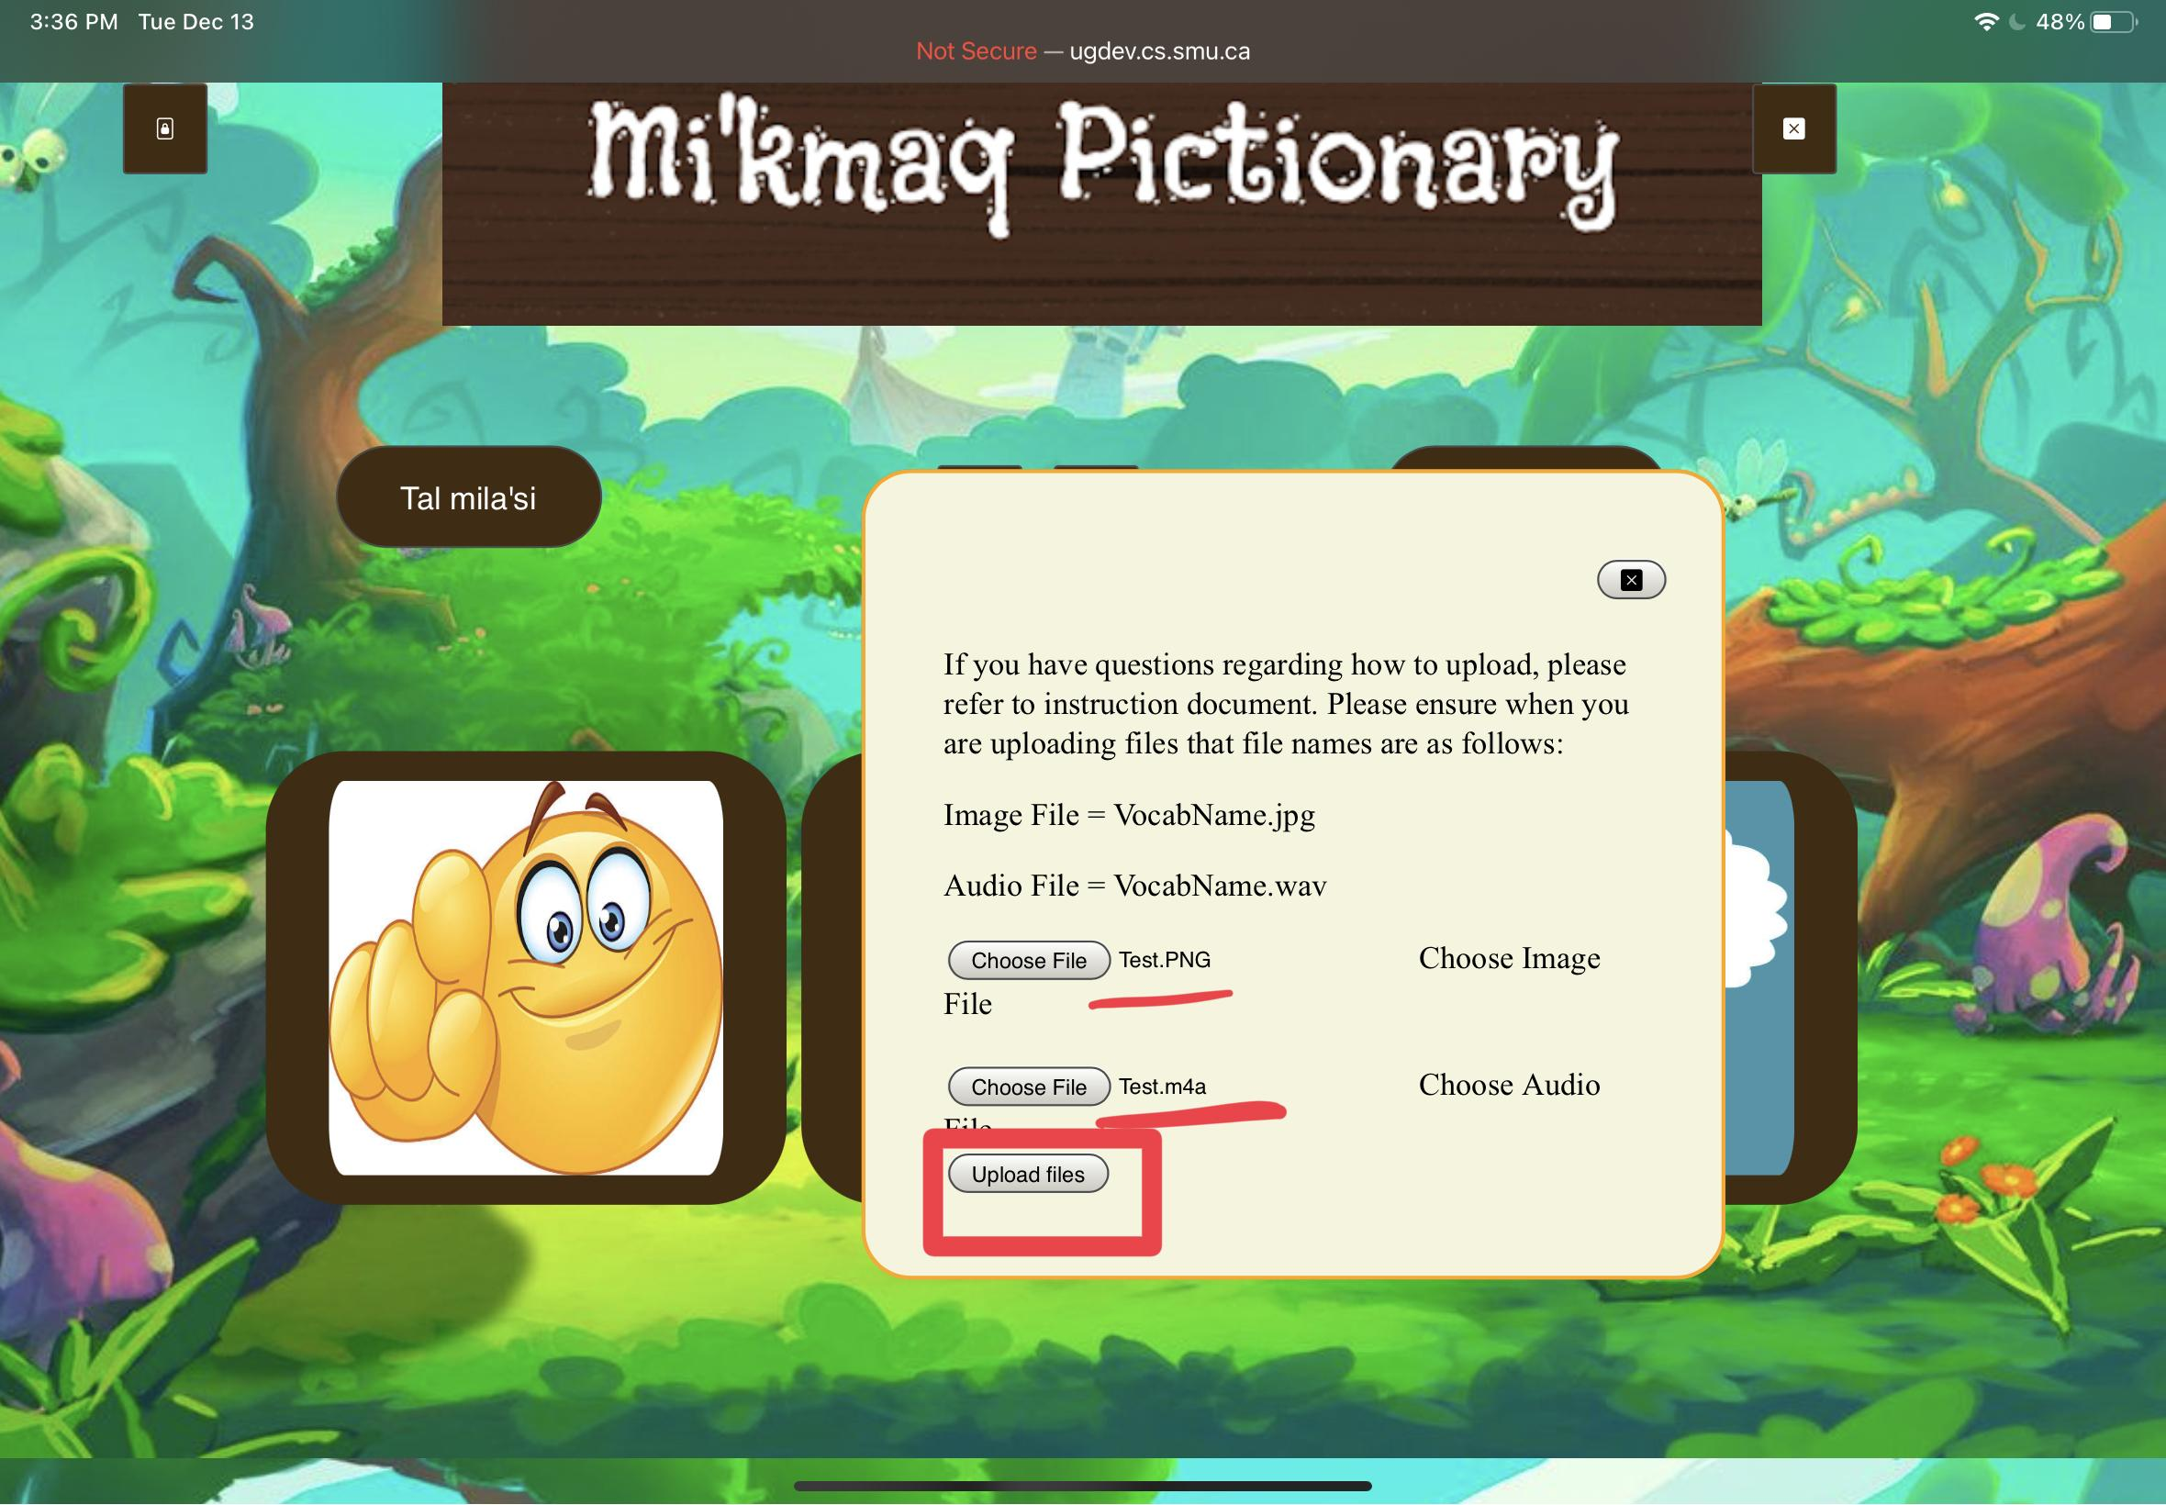
9. You should be met with a screen similar to this one if successful. If something else appears like an error, check your internet connection before trying again. Ensure your files have been named appropriately according to the rules.